

**Gift ecommerce website**

**Software Design Document**

– Ho Chi Minh City, May 2023 –

**Table of Contents**

**I. Overview 4**

1. Code Packages/Namespaces 4

2. Database Schema 5

**II. Code Designs 6**

1. <Authentication/Login/Register/Log out> 6

a. Class Diagram 7

b. Class Specifications 7

AuthController 7

User 8

c. Sequence Diagram(s) 10

d. Database queries 11

2. <Manage Account Profile/View profile/Edit profile> 12

a. Class Diagram 12

b. Class Specifications 12

c. Sequence Diagram(s) 14

d. Database queries 16

Get user by username 16

Get user by email 16

Get user by roleId 16

Get user with enabled status by username or email 16

Get users by role id and enabled 16

Update user enabled by username or email 16

Filter user by firstname and lastname by role id and enabled 16

Get reset token password 16

Get user ex time 16

3. <View product in shop/View product/Search product> 17

a. Class Diagram 17

b. Class Specifications 17

c. Sequence Diagram(s) 21

d. Database queries 22

4. <Manage Product/View product/Create product/edit product/delete product/search product> 23

a. Class Diagram 23

b. Class Specifications 24

c. Sequence Diagram(s) 26

d. Database queries 29

Filter products by category and name 29

Filter the products with their name and their status 29

Get product by productId and status 29

Get Products by email and order by p.id ASC 29

5. <Manage Cart/View cart/Add to cart/Delete product in cart/Edit product quantity in cart> 30

a. Class Diagram 30

b. Class Specifications 31

c. Sequence Diagram(s) 34

d. Database queries 36

6. <Customer Manage Order/Checkout/View orders placed/View detail of each order> 37

a. Class Diagram 37

b. Class Specifications 37

c. Sequence Diagram(s) 38

View orders 40

d. Database queries 40

7. <Manage staff/View staff list/View detail staff profile/Edit staff profile/Add new staff/ Delete staff> 40

a. Class Diagram 40

b. Class Specifications 41

c. Sequence Diagram(s) 44

d. Database queries 46

Get user by username 46

Get user by email 46

Get user by roleId 46

Get user with enabled status by username or email 46

Get users by role id and enabled 46

Update user enabled by username or email 46

Filter user by firstname and lastname by role id and enabled 46

8. <Staff Manage order/View orders/View detail of each order/Refuse/Confirm orders> 47

a. Class Diagram 47

b. Class Specifications 48

c. Sequence Diagram(s) 48

d. Database queries 49

9. <Statistic> 50

a. Class Diagram 50

b. Class Specifications 50

c. Sequence Diagram(s) 52

d. Database queries 52

**III. Database Tables 53**

1. <Order> 54

2. <Order Detail> 55

3. <payment_method> 55

4. <cart> 55

5. <category> 56

6. <user> 56

7. <role> 57

8. <product> 57

9. <product_image> 58

# **I. Overview**

## **1. Code Packages/Namespaces**

*[Provide the package diagram for each sub-system. The content of this section including the overall package diagram, the explanation, package and class naming conventions in each package. Please see the sample and description table format below – following Java project naming convention]*

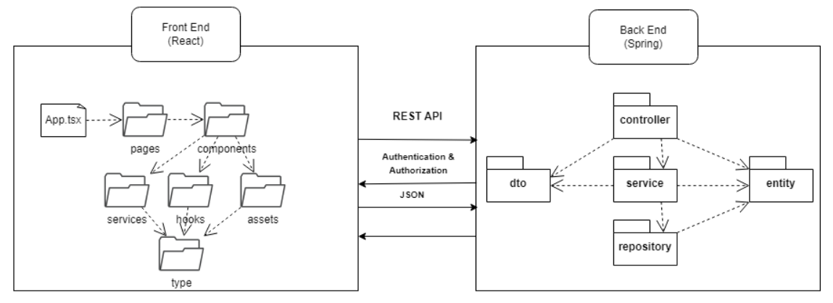

***Package descriptions & package class naming conventions***

|  |  |  |
| --- | --- | --- |
| **No** | **Package** | **Description** |
| *01* | *controller* | * *Where to hold REST Controller classes.* * *Classname + “Controller” (ex: HomeController.java)* |
| *02* | *service* | * *Where to hold service classes for business logic.* * *Classname + “Service” (ex: OrderService.java)* |
| *03* | *repository* | * *Where to hold repository classes for interacting with database.* * *Classname + “Repository” (ex: OrderRepository.java)* |
| *04* | *entity* | * *Where to hold entity classes for mapping with database’s table.* * *TableName (ex: Order.java)* |
| *05* | *dto* | * *Where to hold classes for transferring data for REST APIs.* * *ClassName + “DTO” (ex: LoginInfoDTO.java)* |
| *06* | *pages* | * *Where to hold comprehensive components for pages.* * *PageName.tsx (ex: Home.tsx)* |
| *07* | *components* | * *Where to hold basic React components.* * *ComponentName.tsx (ex: Header.tsx)* |
| *08* | *services* | * *Where to hold service file like fetch api,...* * *Name + “Service.ts” (ex: ProductService.ts)* |
| *09* | *hooks* | * *Where to hold React custom hook.* * *“use” + HookName.ts (ex: useFetchAPI.ts)* |
| *10* | *assets* | * *Where to hold web assets like images…* |
| *11* | *type* | * *Where to hold defined type & interfaces for dto.* * *TypeName.ts (ex: UserDTO.ts)* |

## 

## **2. Database Schema**

*[Provide the tables relationship like example below – following MySQL database naming convention]*

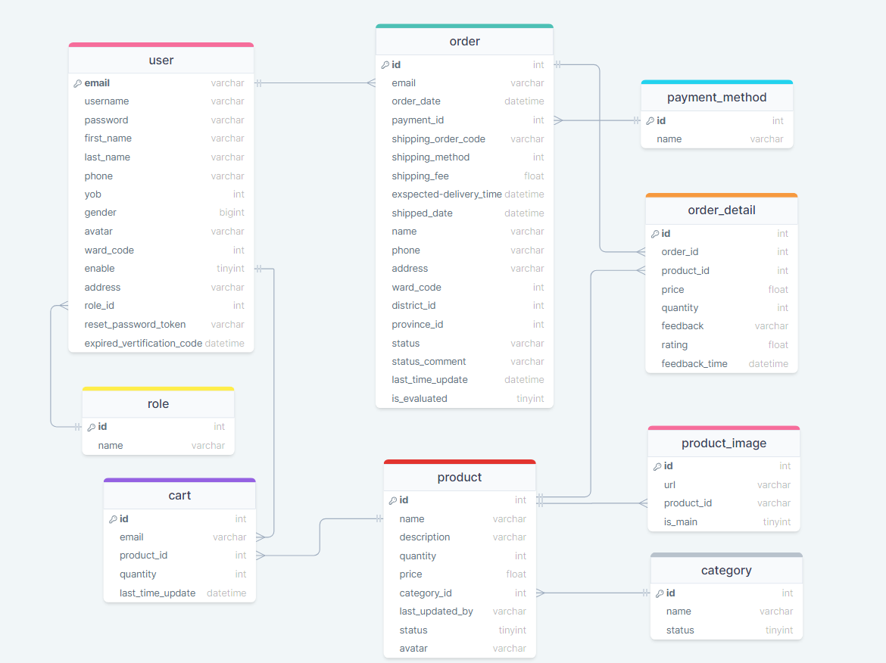

***Table descriptions & package class naming conventions are as below***

|  |  |  |
| --- | --- | --- |
| No | Package | Description |
| *01* | *user* | *contains users’ information*  *Primary keys: email*  *Foreign keys: ward_id* |
| *02* | *role* | *contains users’ roles.*  *Primary keys: id* |
| *03* | *order* | *contains information about orders.*  *Primary keys: id*  *Foreign keys:*  *-email*  *-payment_id*  *-ward_id* |
| *04* | *payment_method* | *contains information about orders.*  *Primary keys: id*  *Foreign keys:*  *-email*  *-payment_id*  *-ward_id* |
| *05* | *order_detail* | *contains information about order details.*  *Primary keys: id*  *Foreign keys:*  *-order_id*  *-product_id* |
| *06* | *product* | *-contains information about the product.*  *-Primary keys: id*  *-Foreign keys:*  *-category_id*  *-last_updated_by* |
| *07* | *category* | *contains a product category list.*  *Primary keys: id* |
| *08* | *product_image* | *contains product images’ information.*  *Primary keys: id*  *Foreign keys:*  *product_id* |
| *09* | *cart* | *contains customer’s product in cart information.*  *Primary keys:*  *-email*  *-product_id*  *-Foreign keys:*  *-email*  *-product_idd* |

# 

# **II. Code Designs**

### 

## **1. <Authentication/Login/Register/Log out>**

### **a. Class Diagram**

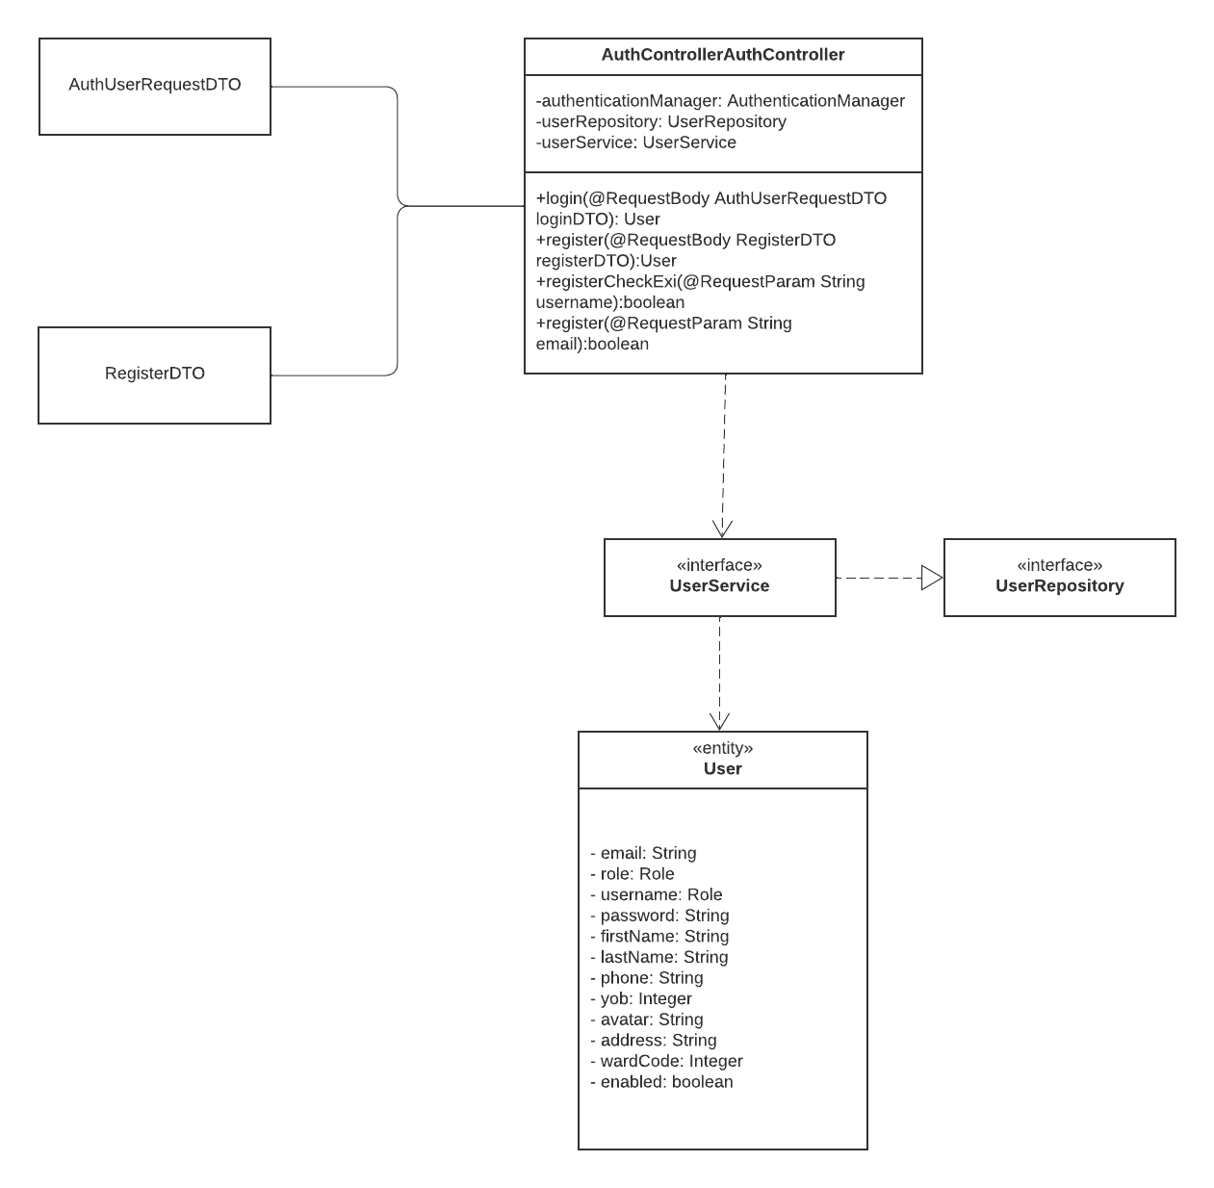

### 

### **b. Class Specifications**

*[Provide the description for each class and the methods in each class, following the table format as below]*

#### ***AuthController***

|  |  |  |
| --- | --- | --- |
| **No** | **Method** | **Description** |
| *01* | *login* | *login(@RequestBody AuthUserRequestDTO loginDTO)* Require users to authenticate their identity before accessing certain features |
| *02* | *register* | register(@RequestBody RegisterDTO registerDTO)  Allows new users to create accounts and gain access to the features and functionality available on the platform |
| *03* | *registerCheckExist* | *registerCheckExist(@RequestParam String username)*  Prevent duplicate registrations and ensure that each user has a unique account within the platform |
| *04* | *register* | *register(@RequestParam String email)*  Require users to authenticate their identity before accessing certain features. @PostMapping("/register/error/email")  Prevent duplicate registrations |

#### ***User***

|  |  |  |
| --- | --- | --- |
| **No** | **Method** | **Description** |
| *01* | *get()* | *Returns the current value of the property* |
| *02* | *set()* | Set new value of the property |
| *03* | *editProfile* | *editProfile(UserProfileDTO userProfile, Role role)*  Allows users to modify their personal profile information |

***UserRepository***

|  |  |  |
| --- | --- | --- |
| **No** | **Method** | **Description** |
| *01* | *getUserByUsername* | *Parameter: String username. This function will find a user by username* |
| *02* | *getUserByEmail* | *Parameter: String email. This function will find a user by email* |
| *03* | *getUsersByRoleId* | *Parameter: Pageable pageable and int roleId. Find the user list by role id* |
| *04* | *getUserByUsernameOrEmail* | *Parameter: String usernameOrEmail. Find the user by username or email* |
| *05* | *getUsersByRoleId* | *Parameter: Pageable pageable and int roleId and boolean enabled. Find the user list by role id with an enabled status: TRUE or FALSE* |
| *06* | *setEnabledByEmail* | *Parameter: String email and enabled. Return integer number of row affected (set enabled)* |
| *07* | *filterUsersByRoleId* | *Parameter: Pageble pageable, int roleId, boolean enabled, and String search. Find the user list by role id with an enabled status: TRUE or FALSE with search element.* |

***Interface UserService was implemented by UserServiceImpl***

| **No** | **Method** | **Description** |
| --- | --- | --- |
| *01* | *getPageableUsers* | *Parameter: int pageNo, int pageSize, int roleId . This function will return a page of user list with role Id and page information is PageNo and PageSize* |
| *02* | *getUserByEmail* | *Parameter: String email. This function will return a user by email* |
| *03* | *getPageableUsers* | *Parameter: int pageNo, int pageSize, int roleId, and boolean enabled . This function will return a page of user list with role Id and enabled status and page information is PageNo and PageSize* |
| *04* | *checkExistUser* | *Parameter: String usernameOrEmail. Return boolean, check that user is exist or not: TRUE or FALSE* |
| *05* | *getUserByEmailOrUsername* | *Parameter: String usernameOrEmail and boolean enabled. Return user by username or email and their enabled* |
| *06* | *setEnabledUserByEmail* | *Parameter: String email and UserProfileDTO. Return user after update their profile* |
| *07* | *updateUserProfile* | *Parameter: Pageable pageable, int roleId, boolean enabled, and String search. Find the user list by role id with an enabled status: TRUE or FALSE with search element.* |
| *08* | *createUser* | *Parameter: User user. Return user after that created* |
| *09* | *searchUsers* | *Parameter: int pageNo, int pageSize, int roleId, boolean enabled and String search. This function will return a page of user list with role Id and enabled status and page information is PageNo and PageSize with a search element* |
| *10* | *register* | *Parameter: RegisterDTO form. Return an user after register successfully* |
| *11* | *updateResetPassword* | *Parameter: String token, String email. This function was used to reset the password of a user account* |
| *12* | *getResetPasswordToken* | *Parameter: String resetPasswordToken. This function will return the User that is reset password token* |
| *13* | *updateUserPassword* | *Parameter: User user, String password. This function was used to update new password of the user with that parameter* |
| *14* | *getExTime* | *Parameter: String token. This function will return the user that get ex time* |

### **c. Sequence Diagram(s)**

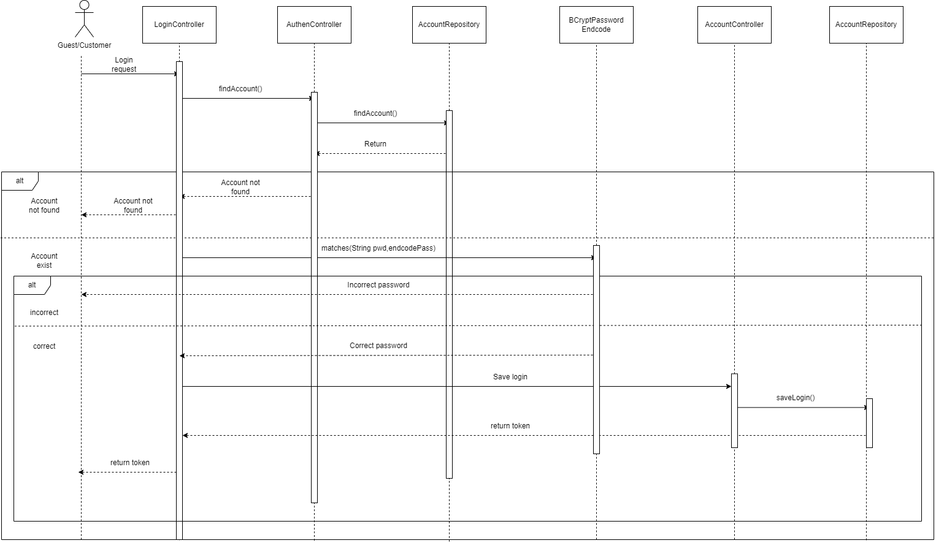

Login sequence diagram

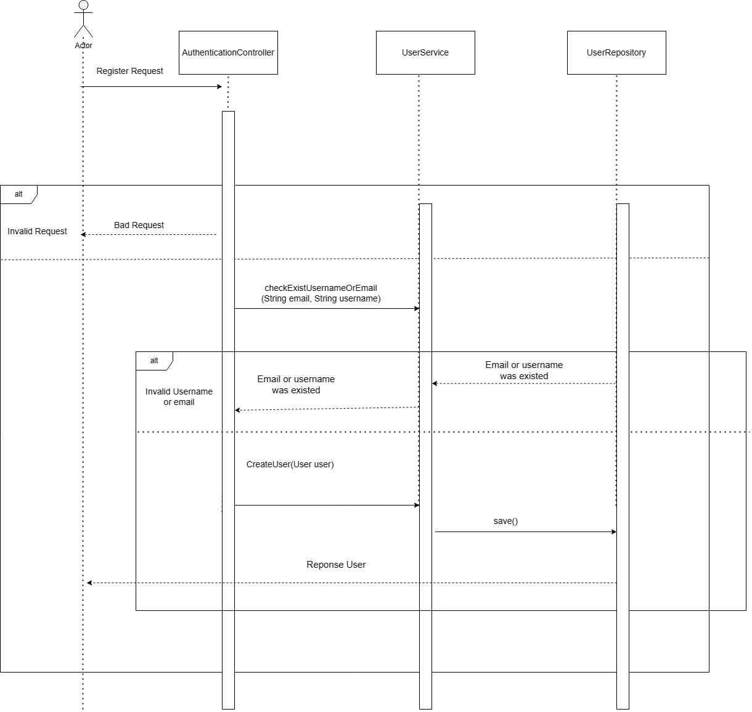

Register User

### **d. Database queries**

**GetUserByUsername**

SELECT u FROM User u WHERE u.username = :username

**GetUserByEmail**

SELECT u FROM User u WHERE u.email = :email

**GetUsersByRoleId**

SELECT u FROM User u WHERE u.role.id = :roleId

**FilterUsersByRoleId**

SELECT u FROM User u WHERE u.role.id = :roleId AND u.enabled = :enabled AND (u.username LIKE %:search% "OR u.email LIKE %:search% OR (u.firstName || ' ' || u.lastName LIKE %:search%))

## **2. <Manage Account Profile/View profile/Edit profile>**

### **a. Class Diagram**

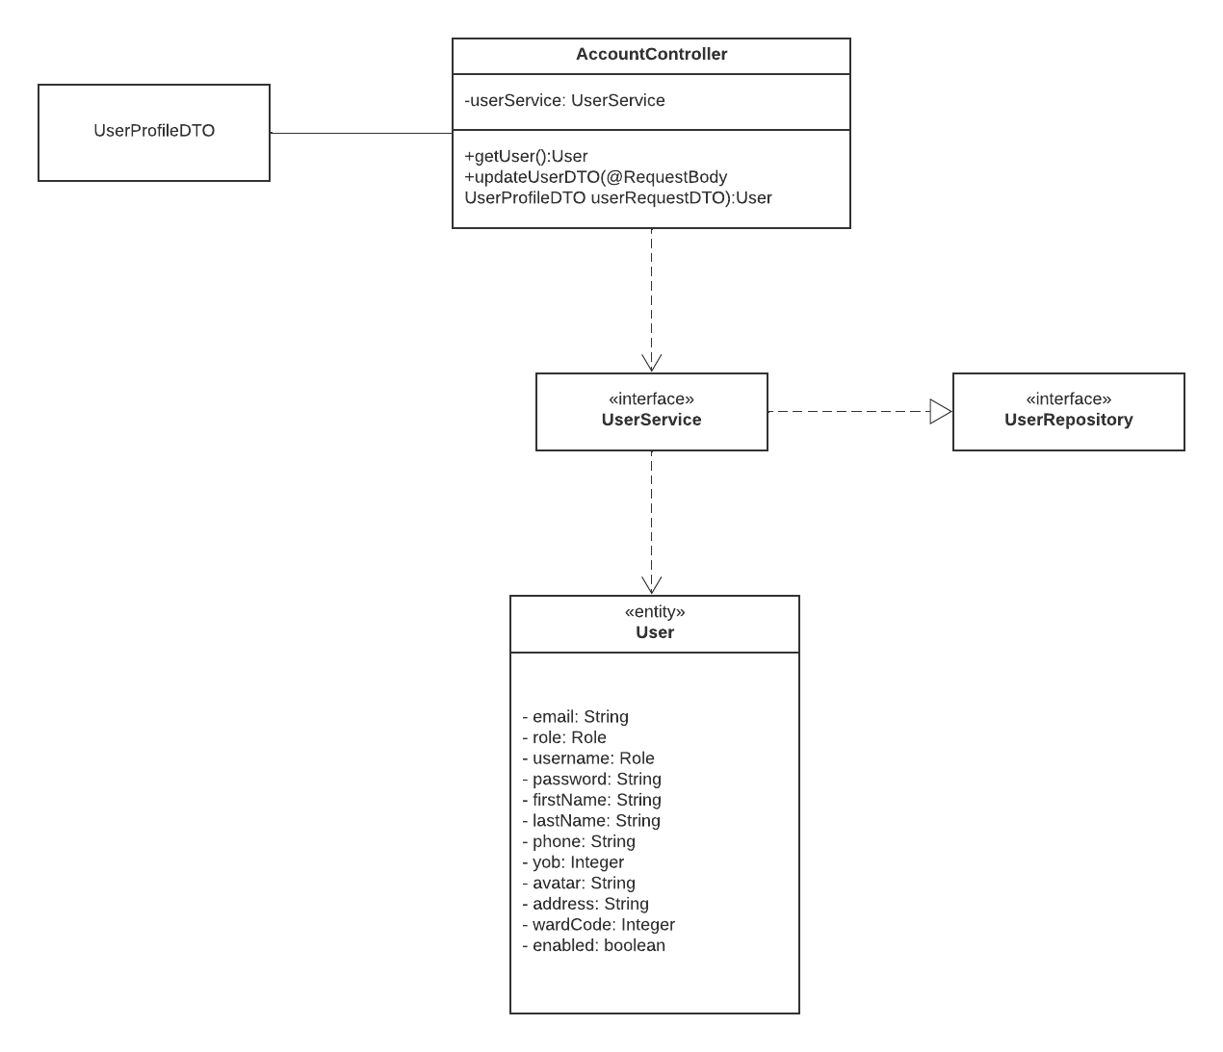

### **b. Class Specifications**

***UserRepository***

|  |  |  |
| --- | --- | --- |
| **No** | **Method** | **Description** |
| *01* | *getUser* | *Parameter: No parameter. This function will return a user that login in the system* |
| *02* | *updateUserDTO* | *Parameter: UserProfileDTO u. This function was used to update the user in database with the parameter profile* |

***Interface UserService was implemented by UserServiceImpl***

|  |  |  |
| --- | --- | --- |
| **No** | **Method** | **Description** |
| *01* | *getPageableUsers* | *Parameter: int pageNo, int pageSize, int roleId . This function will return a page of user list with role Id and page information is PageNo and PageSize* |
| *02* | *getUserByEmail* | *Parameter: String email. This function will return a user by email* |
| *03* | *getPageableUsers* | *Parameter: int pageNo, int pageSize, int roleId, and boolean enabled . This function will return a page of user list with role Id and enabled status and page information is PageNo and PageSize* |
| *04* | *checkExistUser* | *Parameter: String usernameOrEmail. Return boolean, check that user is exist or not: TRUE or FALSE* |
| *05* | *getUserByEmailOrUsername* | *Parameter: String usernameOrEmail and boolean enabled. Return user by username or email and their enabled* |
| *06* | *setEnabledUserByEmail* | *Parameter: String email and UserProfileDTO. Return user after update their profile* |
| *07* | *updateUserProfile* | *Parameter: Pageable pageable, int roleId, boolean enabled, and String search. Find the user list by role id with an enabled status: TRUE or FALSE with search element.* |
| *08* | *createUser* | *Parameter: User user. Return user after that created* |
| *09* | *searchUsers* | *Parameter: int pageNo, int pageSize, int roleId, boolean enabled and String search. This function will return a page of user list with role Id and enabled status and page information is PageNo and PageSize with a search element* |
| *10* | *register* | *Parameter: RegisterDTO form. Return an user after register successfully* |
| *11* | *updateResetPassword* | *Parameter: String token, String email. This function was used to reset the password of a user account* |
| *12* | *getResetPasswordToken* | *Parameter: String resetPasswordToken. This function will return the User that is reset password token* |
| *13* | *updateUserPassword* | *Parameter: User user, String password. This function was used to update new password of the user with that parameter* |
| *14* | *getExTime* | *Parameter: String token. This function will return the user that get ex time* |

***UserRepository***

|  |  |  |
| --- | --- | --- |
| **No** | **Method** | **Description** |
| *01* | *getUserByUsername* | *Parameter: String username. This function will find a user by username* |
| *02* | *getUserByEmail* | *Parameter: String email. This function will find a user by email* |
| *03* | *getUsersByRoleId* | *Parameter: Pageable pageable and int roleId. Find the user list by role id* |
| *04* | *getUserByUsernameOrEmail* | *Parameter: String usernameOrEmail. Find the user by username or email* |
| *05* | *getUsersByRoleId* | *Parameter: Pageable pageable and int roleId and boolean enabled. Find the user list by role id with an enabled status: TRUE or FALSE* |
| *06* | *setEnabledByEmail* | *Parameter: String email and enabled. Return integer number of row affected (set enabled)* |
| *07* | *filterUsersByRoleId* | *Parameter: Pageable pageable, int roleId, boolean enabled, and String search. Find the user list by role id with an enabled status: TRUE or FALSE with search element.* |
| *08* | *getResetPasswordToken* | *Parameter: String token. This function will return the reset password token* |
| *10* | *getExTime* | *Parameter: String token. This function will return the user that get ex time* |
|  |  |  |
|  |  |  |
|  |  |  |

***User***

|  |  |  |
| --- | --- | --- |
| *01* | *get()* | *Returns the current value of the property* |
| *02* | *set()* | Set new value of the property |
| *03* | *editProfile* | *editProfile(UserProfileDTO userProfile, Role role)*  Allows users to modify their personal profile information |

### **c. Sequence Diagram(s)**

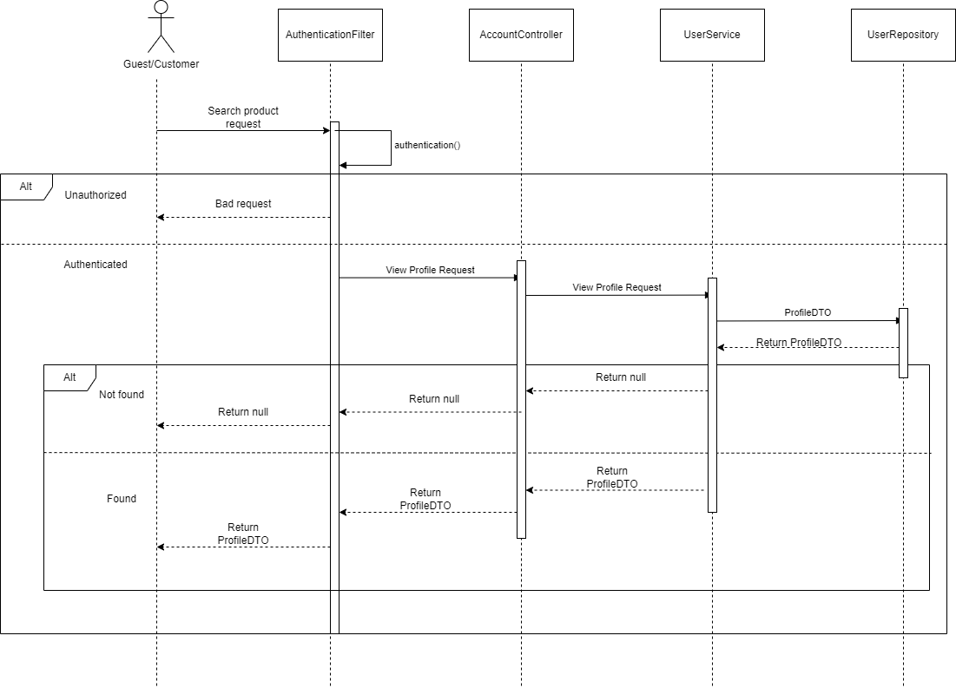

View Account profile

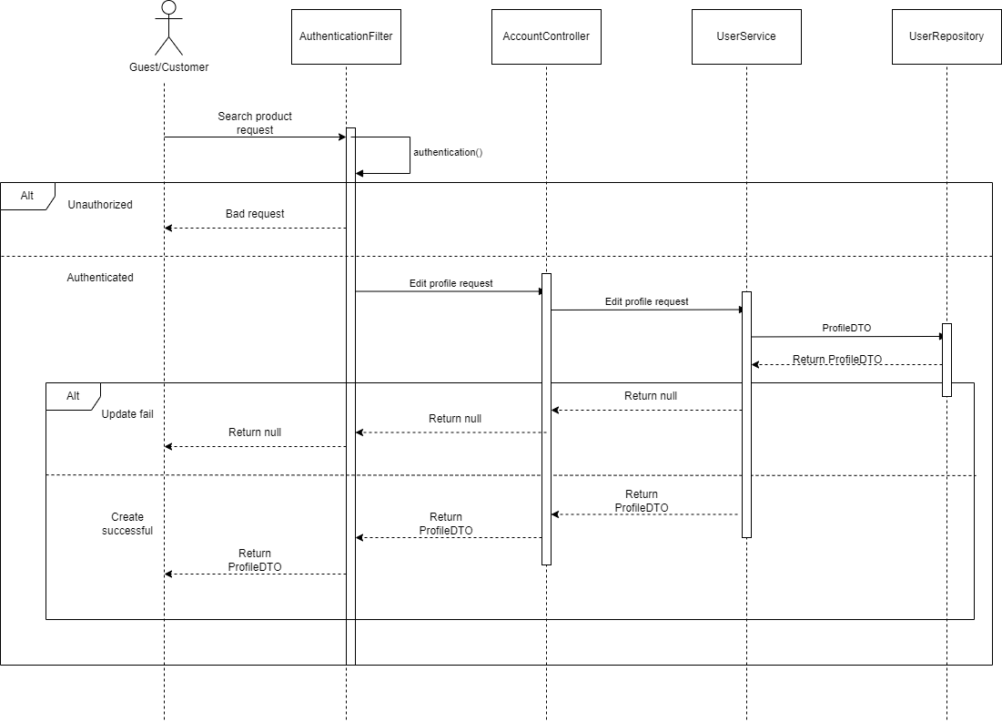

Update Account profile

### **d. Database queries**

### **Get user by username**

SELECT u FROM User u WHERE u.username = :username

### **Get user by email**

SELECT u FROM User u WHERE u.email = :email

### **Get user by roleId**

SELECT u FROM User u WHERE u.role.id = :roleId

### **Get user with enabled status by username or email**

SELECT u FROM User u WHERE u.enabled = :enabled and (u.email = :check OR u.username = :check)

### **Get users by role id and enabled**

SELECT u FROM User u WHERE u.role.id = :roleId AND u.enabled = :enabled

### **Update user enabled by username or email**

UPDATE User u SET u.enabled = :enabled WHERE

u.email = :emailOrUsername OR u.username = :emailOrUsername)

### **Filter user by firstname and lastname by role id and enabled**

SELECT u FROM User u

WHERE u.role.id = :roleId

AND u.enabled = :enabled AND (u.username LIKE %:search%

OR u.email LIKE %:search% OR (u.firstName || ' ' || u.lastName LIKE %:search%))"

### **Get reset token password**

SELECT u FROM User u WHERE u.reset_password_token = :token

### **Get user ex time**

SELECT u FROM User u WHERE u.reset_password_token = :token and expired_vertification_code > CURRENT_TIMESTAMP

## **3. <View product in shop/View product/Search product>**

### **a. Class Diagram**

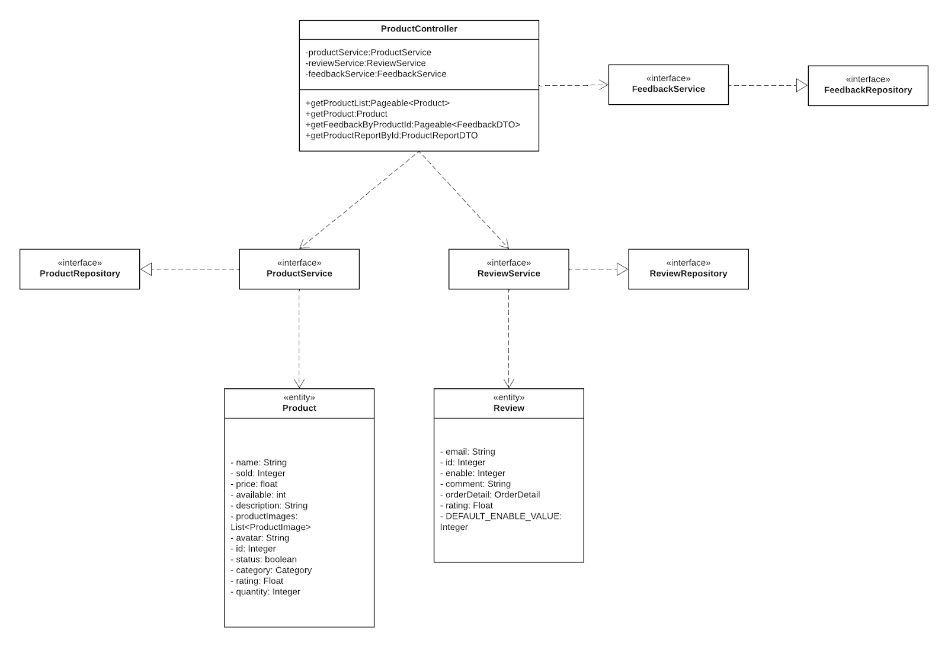

### **b. Class Specifications**

***ProductController***

|  |  |  |
| --- | --- | --- |
| **No** | **Method** | **Description** |
| *01* | *getProductList* | *Parameter:*  *+ int pageNo, int pageSize. This function will return a page of user list with role Id and page information is PageNo and PageSize*  *+ String search, Integer category, String sortField, Boolean sortOrder,*  *Integer related act as data filters according to the condition* |
| *02* | *getProduct* | *Product getProduct(@PathVariable int productId) The implementation of the getProduct() method would typically use the productId parameter to query a database or other data source for details about a specific product* |
| *03* | *getReviewOfProduct* | *Parameter:*  *+ int pageNo, int pageSize. This function will return a page of user list with role Id and page information is PageNo and PageSize*  *+ getReviewOfProduct is a method name that suggests it retrieves reviews for a product.* |

***ProductService***

|  |  |  |
| --- | --- | --- |
| **No** | **Method** | **Description** |
| *01* | *getPageableProducts* | *getPageableProducts(int pageNo, int pageSize)*  *Parameter:*  *+ int pageNo, int pageSize . This function will return a page of user list with role Id and page information is PageNo and PageSize* |
| *02* | *getProductByRelated* | *Product getProduct(@PathVariable int productId) The implementation of the getProduct() method would typically*  *use the productId parameter to query a database or other data source for details about a specific product.*   * *function that returns a collection or list of products that are related to a particular product or item* |
| *03* | *searchProductsByName* | *APIPageableResponseDTO<Product> searchProductsByName(int pageNo, int pageSize, String search, String sortField);*  *+ function that searches for products based on a given name or search query* |
| *04* | *searchProductsByNameInCategory* | *APIPageableResponseDTO<Product> searchProductsByNameInCategory(Integer pageNo, Integer pageSize, String search,*  *Integer category, String sortField);*  *Parameter:*  *+ int pageNo, int pageSize . This function will return a page of user list with role Id and page information is PageNo and PageSize*   * *function that returns a collection or list of products that are related to a particular product or item* |

***ReviewService***

|  |  |  |
| --- | --- | --- |
| **No** | **Method** | **Description** |
| *01* | *findReviewsByProductId* | *Parameter:*  *+ int pageNo, int pageSize . This function will return a page of user list with role Id and page information is PageNo and PageSize*  *+ int productId, int enable. The ID of the product being reviewed*  *The function would then query a database or other data source to find all reviews associated with the specified product ID* |
| *02* | *save* | *Parameter:*   * *RatingRequestDTO ratingRequestDTO contains several properties* * *String email*   *The email parameter may be used to identify the user who submitted the rating, allowing the system to associate the rating with a specific user account.* |

***FeedbackService***

|  |  |  |
| --- | --- | --- |
| **No** | **Method** | **Description** |
| *01* | *getFeedbackByProductId* | *Parameter:*  *+ int pageNo, int pageSize . This function will return a page of user list with role Id and page information is PageNo and PageSize*  *+ int productId. The ID of the product being feedback*  *The function would then query a database or other data source to find all reviews associated with the specified product ID* |

***ProductRepository***

|  |  |  |
| --- | --- | --- |
| **No** | **Method** | **Description** |
| *01* | *finfAllByRealated* | *finfAllByRealated(@Param("status") boolean status,@Param("realated")*   * *function that returns a collection or list of products that are related to a particular product or item* * *finds all products that are related in some way to a particular product, based on the value of the related parameter* |
| *02* | *findProductById* | *Product findProductById(@Param("productId") int productId,*  *@Param("status") boolean status);*  *+ int productId*  *The function would then query a database or other data source with the specified product ID* |
| *03* | *finfAllByName* | *Page<Product> finfAllByName(@Param("status") boolean status,@Param("search") String search,Pageable pageable);*  *+ Pageable pageable . This function will return a page of user list with role Id and page information is PageNo and PageSize*  *+ The function would then query a database or other data source the specified product ID* |
| *04* | *findAllByStatusByNameByCategory* | *Page<Product> findAllByStatusByNameByCategory(@Param("status") boolean status,@Param("search") String search,@Param("category") Integer category, Pageable pageable);*  *+ function that searches for products based on a given name or search query* |

***ReviewRepository***

|  |  |  |
| --- | --- | --- |
| **No** | **Method** | **Description** |
| *01* | *findReviewsByProductId* | *Page<Review> findReviewsByProductId(Pageable pageable, @Param("productId") int productId, int enable);+ int productId. The ID of the product being reviewed*  *Pageable pageable . This function will return a page of user list with role Id and page information is PageNo and PageSize* |

***Product***

|  |  |  |
| --- | --- | --- |
| *01* | *get()* | *Returns the current value of the property* |
| *02* | *set()* | Set new value of the property |
| *03* | *getAvatar()* | Allows users to modify product avatar information |

### **c. Sequence Diagram(s)**

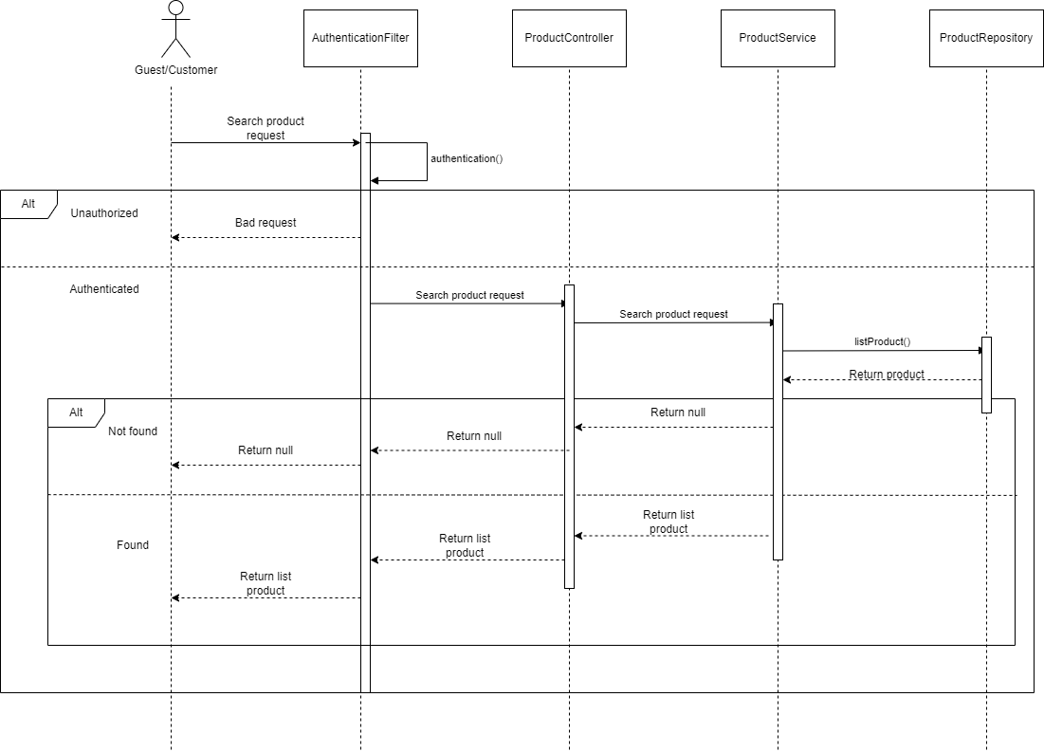

Search product sequence diagram

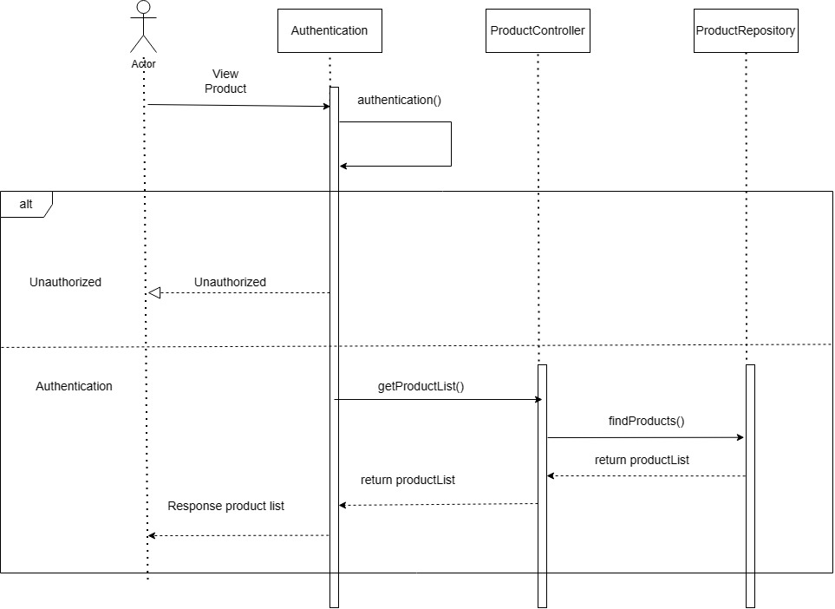

View Products Sequence diagram

### **d. Database queries**

**findAllByStatusByNameByCategory** :

@Query("SELECT p FROM Product p WHERE p.status = :status AND p.category.id = :category AND p.name LIKE %:search%")

**finfAllByName**:

@Query("SELECT p FROM Product p WHERE p.name LIKE %:search% and p.status = :status")

**finfAllByRealated**:

@Query("SELECT p FROM Product p WHERE p.category.id = (SELECT p2.category.id FROM Product p2 WHERE p2.id = :realated) AND p.status = :status ORDER BY RAND()")

**findProductById:**

@Query("SELECT p FROM Product p WHERE p.id = :productId AND p.status = :status")

**findReviewsByProductId:**

@Query("SELECT r FROM Review r WHERE r.orderDetail.productId = :productId AND r.enable = :enable")

## **4. <Manage Product/View product/Create product/edit product/delete product/search product>**

### **a. Class Diagram**

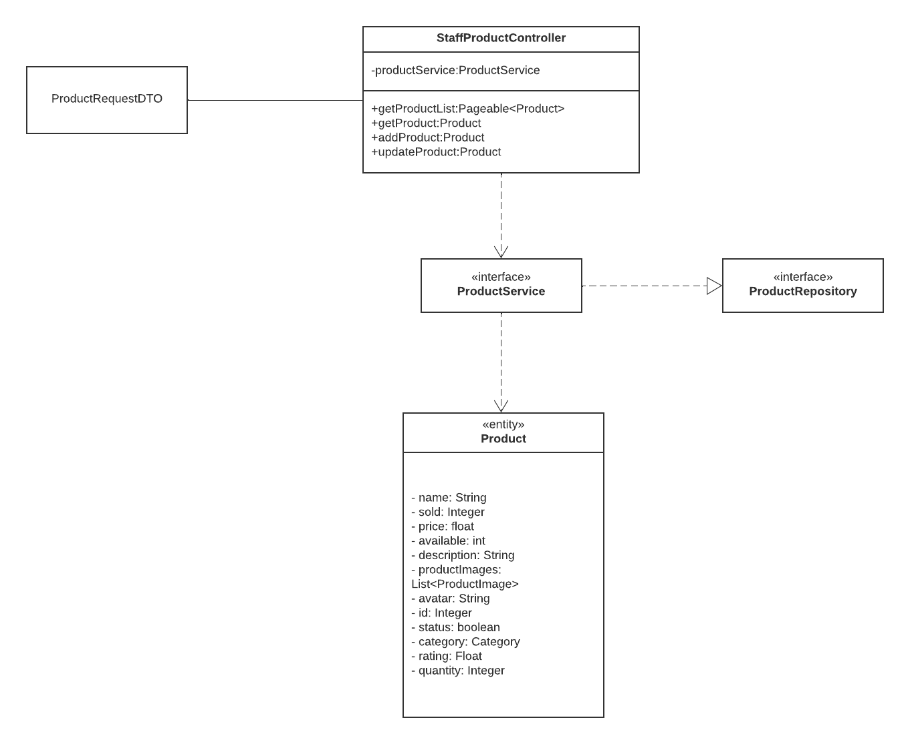

### **b. Class Specifications**

***StaffProductController***

|  |  |  |
| --- | --- | --- |
| **No** | **Method** | **Description** |
| *01* | *getProductList* | *Parameter:*  *+ int pageNo, int pageSize . This function will return a page of user list with role Id and page information is PageNo and PageSize*  *+ String search, Integer category, String sortField, Boolean sortOrder,*  *Integer related act as data filters according to the condition* |
| *02* | *getProduct* | *Parameter: @PathVariable int productId. This function will return a product with the parameter productId is the id of the product* |
| *03* | *addProduct* | *Parameter: @RequestBody ProductRequestDTO productRequestDTO . This function will return a product that you created and save it in database.* |
| *04* | *updateProduct* | *Parameter: @PathVariable int productId, @RequestBody ProductRequestDTO productRequestDTO. This function will return a product that you updated with information productRequestDTO and save it in database* |
| *05* | *deleteCustomerById* | *Parameter:@PathVariable int productId. This function will delete a product in database by parameter productId* |

***ProductService***

|  |  |  |
| --- | --- | --- |
| **No** | **Method** | **Description** |
| *01* | *getPageableProducts* | *getPageableProducts(int pageNo, int pageSize)*  *Parameter:*  *+ int pageNo, int pageSize. This function will return a page of user list with role Id and page information is PageNo and PageSize* |
| *02* | *getProductByRelated* | *Product getProduct(@PathVariable int productId) The implementation of the getProduct() method would typically*  *use the productId parameter to query a database or other data source for details about a specific product.*   * *function that returns a collection or list of products that are related to a particular product or item* |
| *03* | *searchProductsByName* | *APIPageableResponseDTO<Product> searchProductsByName(int pageNo, int pageSize, String search, String sortField);*  *+ function that searches for products based on a given name or search query* |
| *04* | *searchProductsByNameInCategory* | *APIPageableResponseDTO<Product> searchProductsByNameInCategory(Integer pageNo, Integer pageSize, String search,*  *Integer category, String sortField);*  *Parameter:*  *+ int pageNo, int pageSize . This function will return a page of user list with role Id and page information is PageNo and PageSize*   * *function that returns a collection or list of products that are related to a particular product or item* |
| *05* | *save* | *Parameter:Product product. This function will save a product in parameter to the database* |
| *06* | *checkExist* | *Parameter:Product product. This function return true/false check that the product is exist or not* |
| *07* | *delete* | *Parameter:Product product. This function will delete the product in the parameter in the database. return true/false* |
| *08* | *update* | *Parameter:int productId, ProductRequestDTO productRequestDTOt. This function will return user that updated by the information product request by product id* |
| *09* | *createNewProductFrom* | *Parameter: ProductRequestDTO productRequestDTOt. This function will return user that created an save in the database* |
|  |  |  |
|  |  |  |

***ProductRepository***

|  |  |  |
| --- | --- | --- |
| **No** | **Method** | **Description** |
| *01* | *findAllByRealated* | *finfAllByRealated(@Param("status") boolean status,@Param("realated")*   * *function that returns a collection or list of products that are related to a particular product or item* * *finds all products that are related in some way to a particular product, based on the value of the related parameter* |
| *02* | *findProductById* | *Product findProductById(@Param("productId") int productId,*  *@Param("status") boolean status);*  *+ int productId*  *The function would then query a database or other data source with the specified product ID* |
| *03* | *finfAllByName* | *Page<Product> finfAllByName(@Param("status") boolean status,@Param("search") String search,Pageable pageable);*  *+ Pageable pageable . This function will return a page of user list with role Id and page information is PageNo and PageSize*  *+ The function would then query a database or other data source the specified product ID* |
| *04* | *findAllByStatusByNameByCategory* | *Page<Product> findAllByStatusByNameByCategory(@Param("status") boolean status,@Param("search") String search,@Param("category") Integer category, Pageable pageable);*  *+ function that searches for products based on a given name or search query* |

***Product***

|  |  |  |
| --- | --- | --- |
| **No** | **Method** | **Description** |
| *01* | *get()* | *Returns the current value of the property* |
| *02* | *set()* | Set new value of the property |
| *03* | *getAvatar()* | Allows users to modify product avatar information |

### **c. Sequence Diagram(s)**

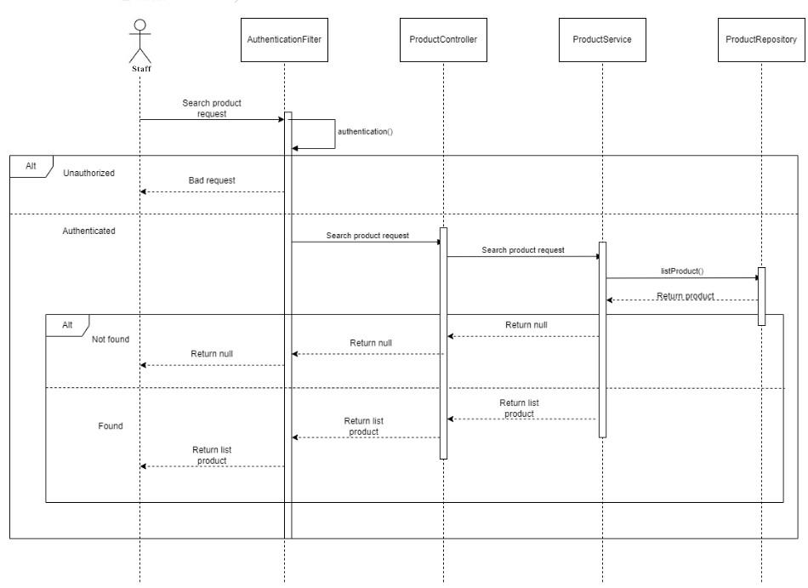

Search product sequence diagram



View Products Sequence diagram

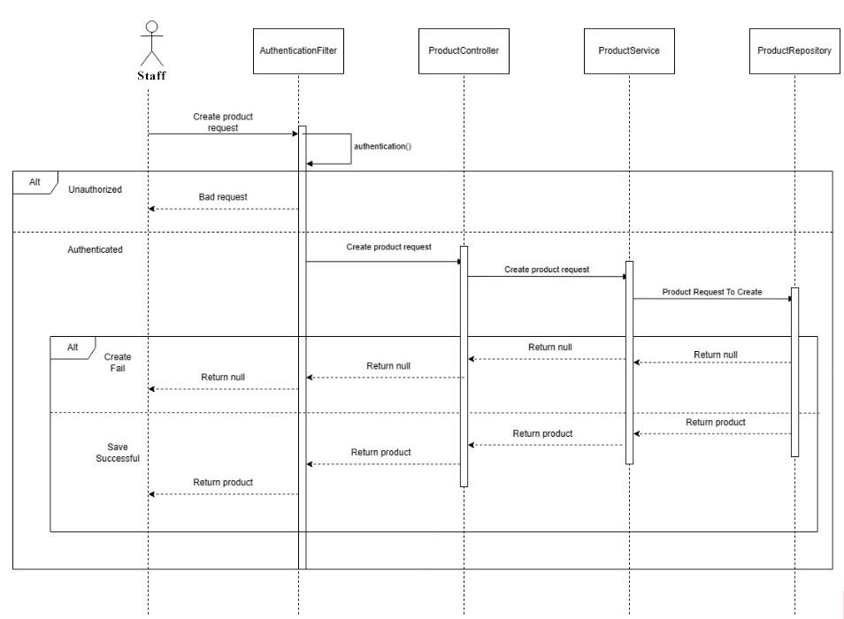

Create Product

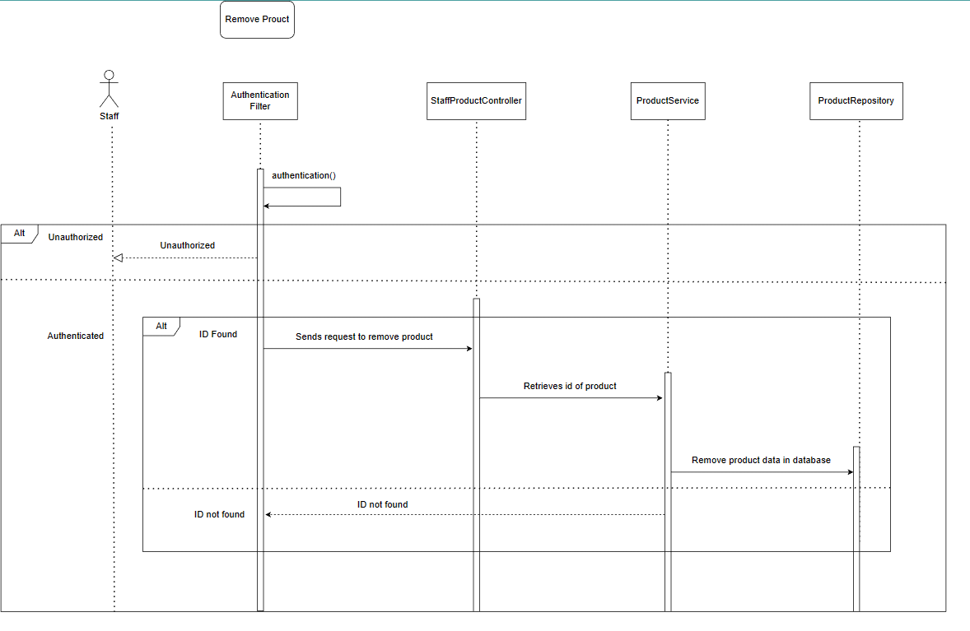

Remove Product

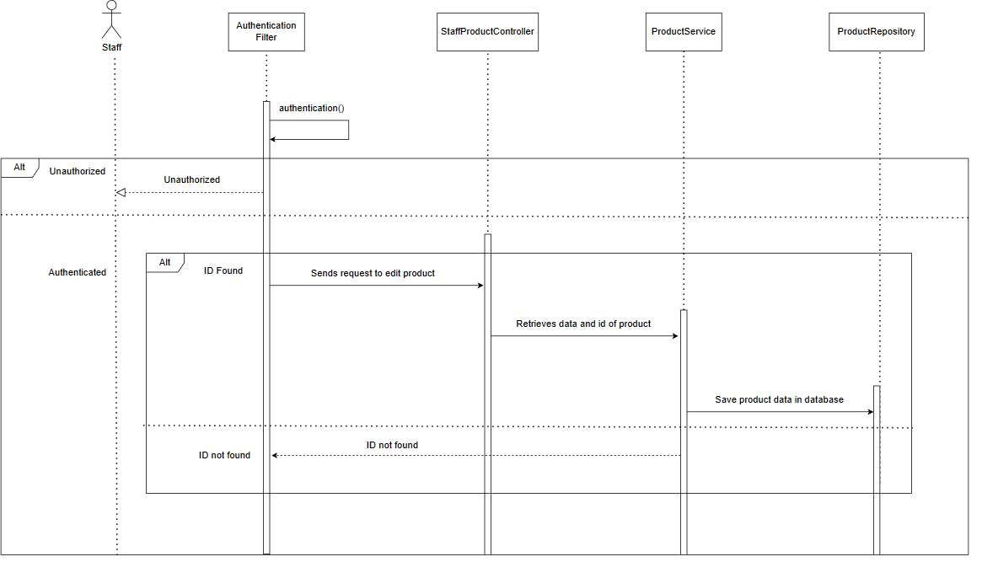

Edit Product

### **d. Database queries**

### **Filter products by category and name**

SELECT p FROM Product p WHERE p.status = :status AND p.category.id = :category AND p.name LIKE %:search

### **Filter the products with their name and their status**

SELECT p FROM Product p WHERE p.name LIKE %:search% and p.status = :status

### **Get product by productId and status**

SELECT p FROM Product p WHERE p.id = :productId AND p.status = :status

### **Get Products by email and order by p.id ASC**

SELECT DISTINCT p

FROM Product p

JOIN OrderDetail od ON p.id = od.productId

JOIN Orders o ON od.orderId = o.id

JOIN User u ON o.email = u.email

WHERE u.email = :email

Order by p.id ASC

## **5. <Manage Cart/View cart/Add to cart/Delete product in cart/Edit product quantity in cart>**

### **a. Class Diagram**

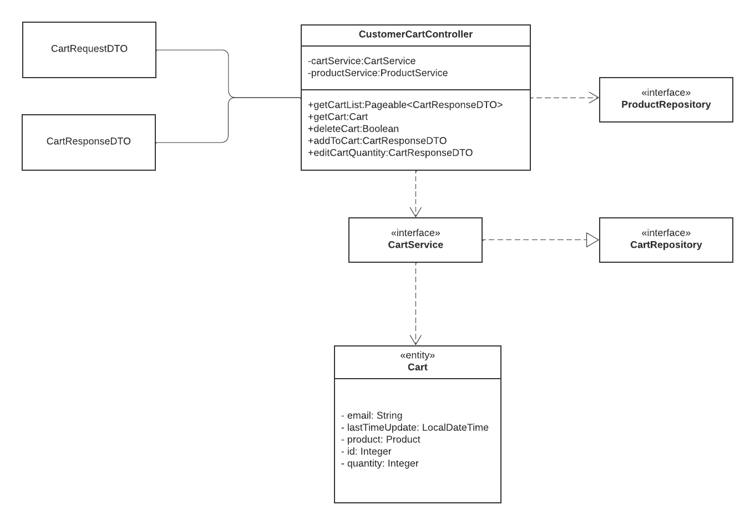

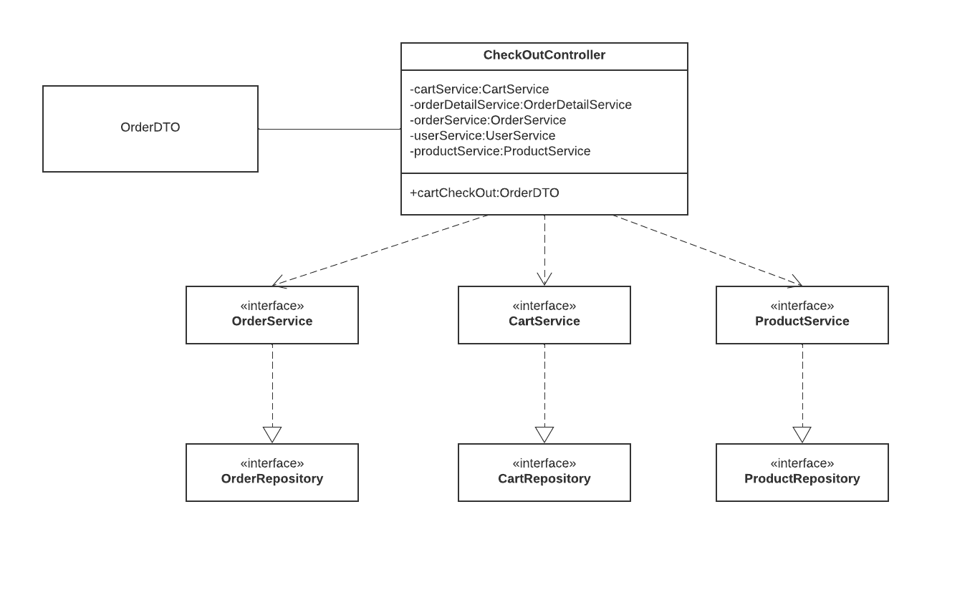

### **b. Class Specifications**

***CustomerCartController***

|  |  |  |
| --- | --- | --- |
| **No** | **Method** | **Description** |
| *01* | *getCartList* | *APIPageableResponseDTO<CartResponseDTO> getCartList*  *Parameter:*  *+ int pageNo, int pageSize . This function will return a page of user list with role Id and page information is PageNo and PageSize*  *+ String search.*  *Function would retrieve a list of items currently present in a user's shopping cart on an e-commerce website or web application* |
| *02* | *getCart* | *Cart getCart(@PathVariable int cartId)*  *Parameter: @PathVariable int cartId. This function will return a Cart with the parameter cartIdis the id of the Cart* |
| *03* | *deleteCart* | *boolean deleteCart(@PathVariable int cartId)*  *Parameter: @PathVariable int cartId. This function will delete a Cart with the parameter cartIdis the id of the Cart* |
| *04* | *addToCart* | *CartResponseDTO addToCart(@RequestBody CartRequestDTO cartDTO)*  *The CartRequestDTO object contains information about the items to be added to the cart*  *The purpose of this method is to add the items specified in the cartDTO object to the user's shopping cart.* |
| *05* | *editCartQuantity* | *CartResponseDTO editCartQuantity(@RequestBody CartRequestDTO cartDTO) The CartRequestDTO object contains information about the item whose quantity needs to be edited*  *The purpose of this method is to edit the quantity of an item in the user's shopping cart.* |

***CartService***

|  |  |  |
| --- | --- | --- |
| **No** | **Method** | **Description** |
| *01* | *getCartByEmailAndProductId* | *Cart getCartByEmailAndProductId(String email, int productId); Find Cart base on String email, int productId* |
| *02* | *getPagableCart* | *APIPageableResponseDTO<CartResponseDTO> getPagableCart(Integer pageNo, Integer pageSize,String email); Get List Cart IPageable* |
| *03* | *getCartByEmailAndCartId* | *Cart getCartByEmailAndCartId(String emai, int cartId);*  *Find Cart base on String email, int CartId* |
| *04* | *refreshCart* | *Cart refreshCart(Cart cart) Reload the cart every time there is an action with the cart* |
| *05* | *getShopAvailableQuantity* | *int getShopAvailableQuantity(int productId);*  *Show AvailableQuantity of product User can add to cart* |
| *06* | *getCustomerAvailableQuantity* | *int getCustomerAvailableQuantity(String email, int productId)*  *Limit quantity of product User can add to cart* |
| *07* | *save* | *Cart save(Cart cart) Save cart info* |
| *08* | *deleteCart* | *deleteCart(String email, int productId); Delete product in cart base on email, productId* |

***CartRepository***

|  |  |  |
| --- | --- | --- |
| **No** | **Method** | **Description** |
| *01* | *findCartByEmailAndProductId* | *Cart findCartByEmailAndProductId(@Param("email") String email, @Param("productId") int productId);*  *Find Cart base on email, producId* |
| *02* | *findCartByEmailAndCartId* | *Cart findCartByEmailAndCartId(@Param("email") String email,*  *@Param("cartId") int cartId);*  *Find Cart base on email, cartId* |
| *03* | *findAllByEmail* | *Page<Cart> findAllByEmail(@Param("email") String email,PageRequest pageRequest); Return a Page Cart of Email parameter (Sort DESC)* |
| *04* | *findAllByEmail* | *Page<Cart> findAllByEmail(@Param("email") String email,PageRequest pageRequest); Return a Page Cart of Email parameter* |

***ProductService***

|  |  |  |
| --- | --- | --- |
| **No** | **Method** | **Description** |
| *01* | *getPageableProducts* | *getPageableProducts(int pageNo, int pageSize)*  *Parameter:*  *+ int pageNo, int pageSize. This function will return a page of user list with role Id and page information is PageNo and PageSize* |
| *02* | *getProductByRelated* | *Product getProduct(@PathVariable int productId) The implementation of the getProduct() method would typically*  *use the productId parameter to query a database or other data source for details about a specific product.*   * *function that returns a collection or list of products that are related to a particular product or item* |

***ProductRepository***

|  |  |  |
| --- | --- | --- |
| **No** | **Method** | **Description** |
| *01* | *findProductById* | *Product findProductById(@Param("productId") int productId,*  *@Param("status") boolean status);*  *+ int productId*  *The function would then query a database or other data source with the specified product ID* |
| *02* | *finfAllByName* | *Page<Product> finfAllByName(@Param("status") boolean status,@Param("search") String search,Pageable pageable);*  *+ Pageable pageable . This function will return a page of user list with role Id and page information is PageNo and PageSize*  *+ The function would then query a database or other data source the specified product ID* |

***Carts***

|  |  |  |
| --- | --- | --- |
| **No** | **Method** | **Description** |
| *01* | *get()* | *Returns the current value of the property* |
| *02* | *set()* | Set new value of the property |

***Product***

|  |  |  |
| --- | --- | --- |
| **No** | **Method** | **Description** |
| *01* | *get()* | *Returns the current value of the property* |
| *02* | *set()* | Set new value of the property |

### **c. Sequence Diagram(s)**

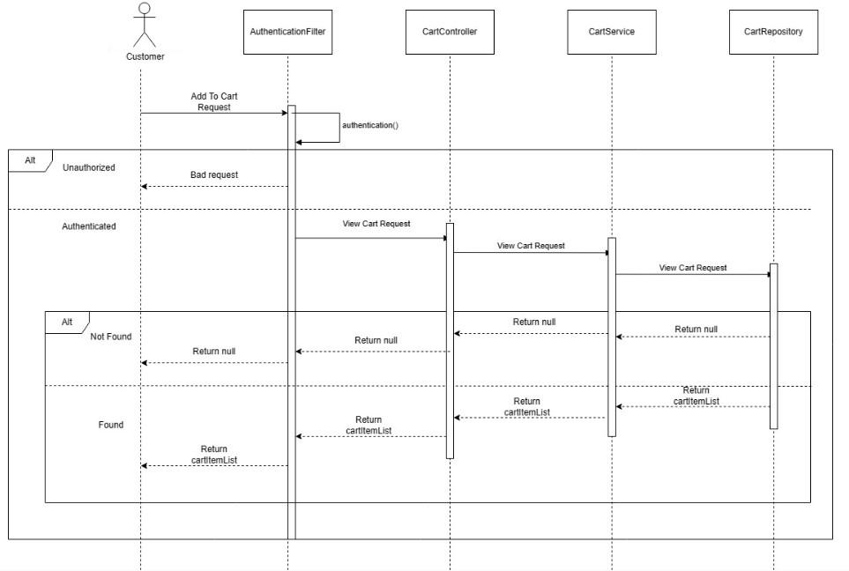

**View Cart**

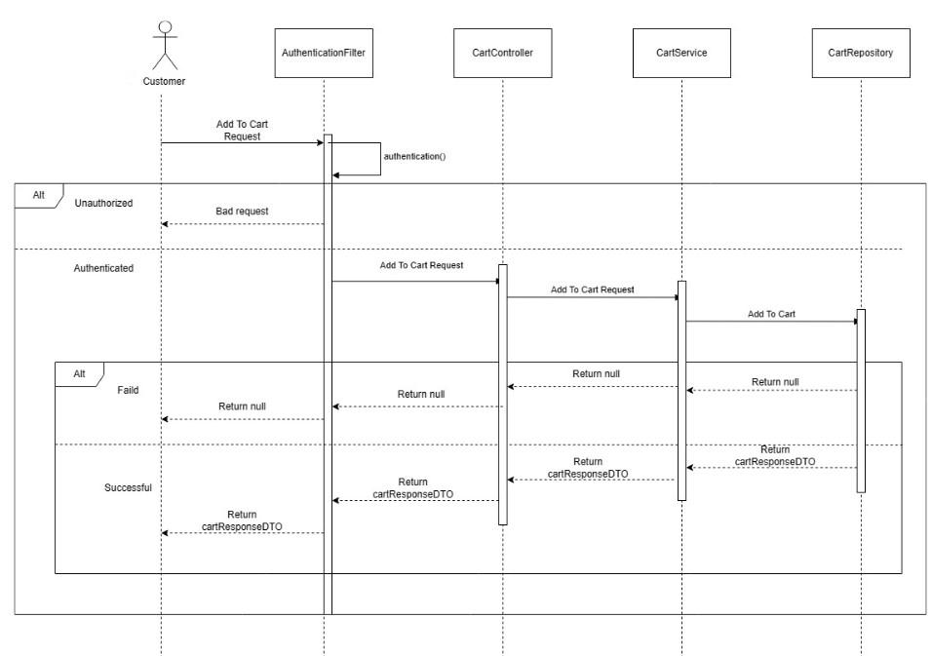

**Add To Cart**

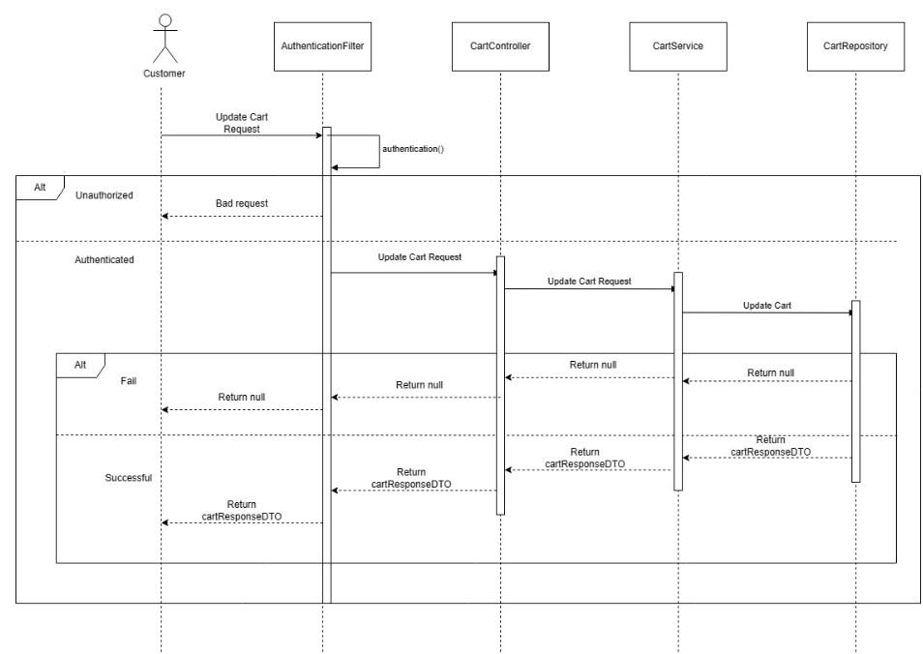

**Edit Cart**

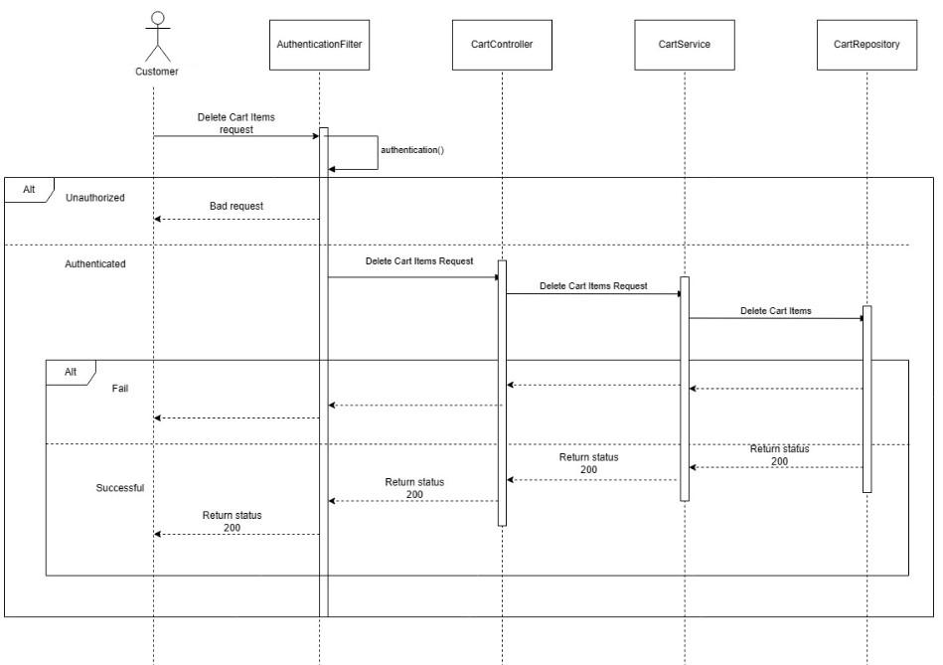

**Delete Cart Item**

### **d. Database queries**

**FindCartByEmailAndProductId:**

SELECT cart FROM Cart cart WHERE cart.email = :email AND cart.product.id = :productId")

**FindCartByEmailAndCartId:**

SELECT c FROM Cart c WHERE c.email = :email AND c.id = :cartId

**FindAllByEmail:**

SELECT c FROM Cart c WHERE c.email = :email ORDER BY c.lastTimeUpdate DESC

**FindAllByEmail:**

SELECT c FROM Cart c WHERE c.email = :email

## **6. <Customer Manage Order/Checkout/View orders placed/View detail of each order>**

### **a. Class Diagram**

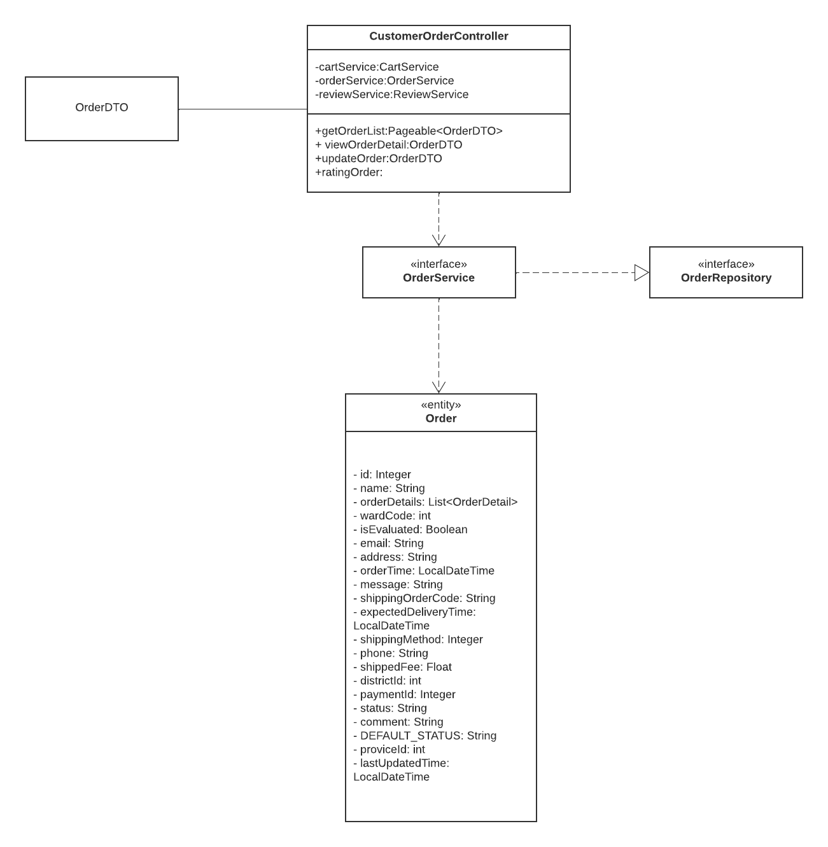

### **b. Class Specifications**

### 

***CustomerOrderController***

|  |  |  |
| --- | --- | --- |
| **No** | **Method** | **Description** |
| *01* | *getOrderList* | *Parameter:*  *+ @RequestParam Integer pageNo, @RequestParam Integer pageSize, @RequestParam String status*  *. This function will return a page of order list with pageable* |
| *02* | *viewOrderDetail* | *Parameter: @PathVariable int orderId. This function will return OrderDTO to view the order detail of a order with orderId* |

***OrderService***

|  |  |  |
| --- | --- | --- |
| **No** | **Method** | **Description** |
| *01* | *getOrderByOrderId* | *Parameter:Integer orderId. This function will return a order with orderId* |
| *02* | *getOrderList* | *Parameter: Integer pageNo, Integer pageSize, String email. This function will return the page of orders with pageable* |

***OrderRepository***

|  |  |  |
| --- | --- | --- |
| **No** | **Method** | **Description** |
| *01* | *findOrderByOrderId* | *Parameter:@Param Integer orderId. This function will return a order with orderId* |
| *02* | *getOrderedWithStatus* | *Parameter: String status, PageRequest pageRequest. This function will return the page of orders with pageable* |

### **c. Sequence Diagram(s)**

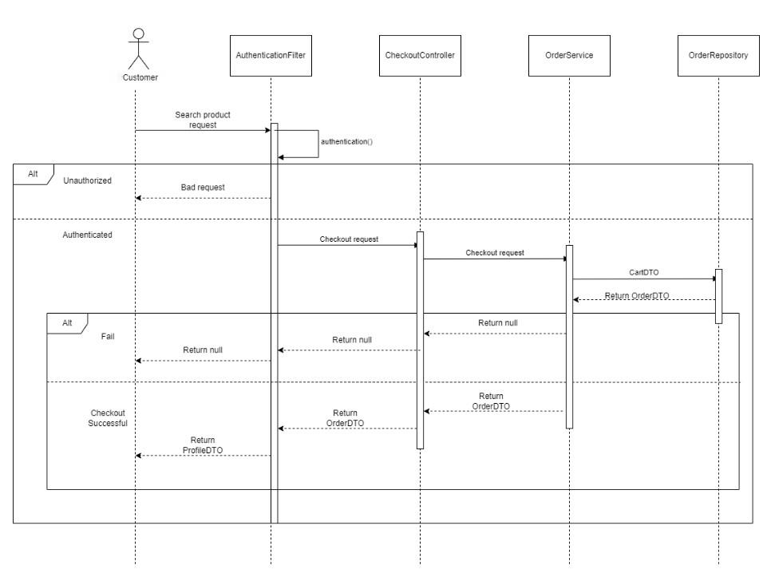Check out diagram  
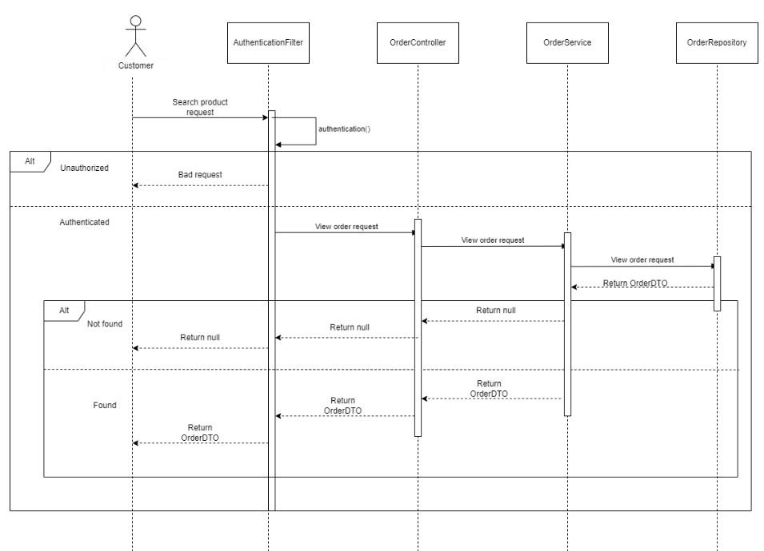

## **View orders**

### **d. Database queries**

**Get order by order id**

SELECT o FROM Orders o WHERE o.id = :orderId

**Get order list by with status**

SELECT p FROM Orders p WHERE p.status like %:status%

**FindAllByEmail**

SELECT o FROM Orders o WHERE o.email = :email ORDER BY o.orderTime DESC

**FindAllWithStatus**

SELECT o FROM Orders o WHERE o.status in :statuses ORDER BY o.orderTime DESC

## **7. <Manage staff/View staff list/View detail staff profile/Edit staff profile/Add new staff/ Delete staff>**

### **a. Class Diagram**

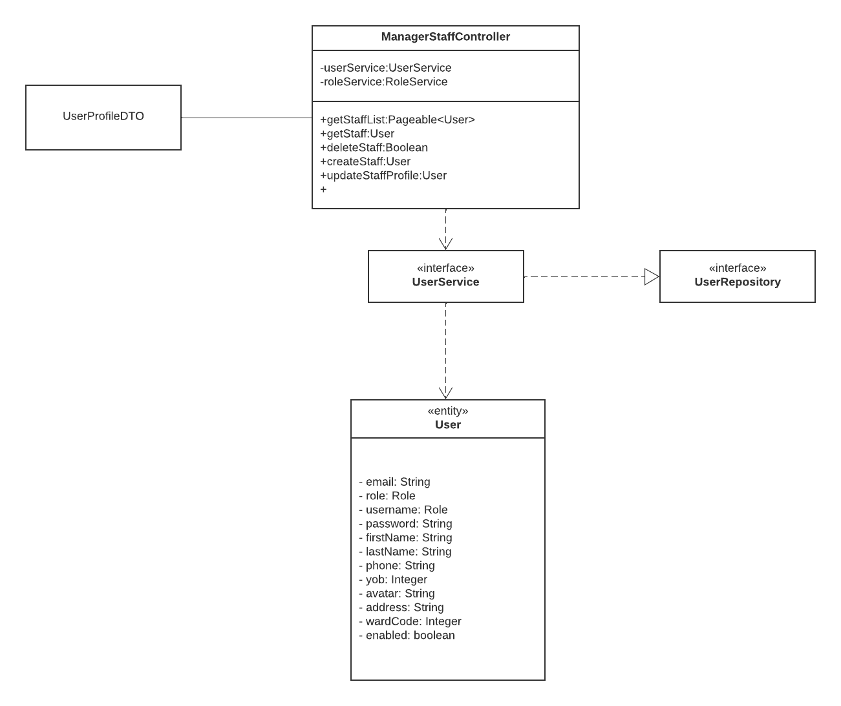

### **b. Class Specifications**

***MangerStaffController***

|  |  |  |
| --- | --- | --- |
| **No** | **Method** | **Description** |
| *01* | *getStaffList* | *APIPageableResponseDTO<User> getStaffList()*  *Parameter:*  *+ int pageNo, int pageSize . This function will return a page of user list with role Id and page information is PageNo and PageSize*  *+ String search.*  *Function would retrieve a list of Staff* |
| *02* | *getStaff* | *User getStaff(@PathVariable String check)*  *Parameter: @PathVariable String check. This function will return a User staff with the parameter String check* |
| *03* | *deleteCart* | *boolean deleteStaff(@PathVariable String check)*  *Parameter: @PathVariable String check. This function will delete a User staff with the parameter String check* |
| *04* | *createStaff* | *User createStaff(@RequestBody User user)*  *The user object contains information about the items to be added to the cart*  *The purpose of this method is to add the user specified in the role staff.* |
| *05* | *updateStaffProfile* | *User updateStaffProfile(@PathVariable String check,*  *@RequestBody UserProfileDTO userProfile)*  *The userProfile object contains information about the information needs to be edited*  *The purpose of this method is to edit the information of the user's.* |

***UserService***

| **No** | **Method** | **Description** |
| --- | --- | --- |
| *01* | *getPageableUsers* | *Parameter: int pageNo, int pageSize, int roleId . This function will return a page of user list with role Id and page information is PageNo and PageSize* |
| *02* | *getUserByEmail* | *Parameter: String email. This function will return a user by email* |
| *03* | *getPageableUsers* | *Parameter: int pageNo, int pageSize, int roleId, and boolean enabled . This function will return a page of user list with role Id and enabled status and page information is PageNo and PageSize* |
| *04* | *checkExistUser* | *Parameter: String usernameOrEmail. Return boolean, check that user is exist or not: TRUE or FALSE* |
| *05* | *getUserByEmailOrUsername* | *Parameter: String usernameOrEmail and boolean enabled. Return user by username or email and their enabled* |
| *06* | *setEnabledUserByEmail* | *Parameter: String email and UserProfileDTO. Return user after update their profile* |
| *07* | *updateUserProfile* | *Parameter: Pageable pageable, int roleId, boolean enabled, and String search. Find the user list by role id with an enabled status: TRUE or FALSE with search element.* |
| *08* | *createUser* | *Parameter: User user. Return user after that created* |
| *09* | *searchUsers* | *Parameter: int pageNo, int pageSize, int roleId, boolean enabled and String search. This function will return a page of user list with role Id and enabled status and page information is PageNo and PageSize with a search element* |

***UserRepository***

|  |  |  |
| --- | --- | --- |
| **No** | **Method** | **Description** |
| *01* | *getUserByUsername* | *User getUserByUsername(@Param("username") String username);*  *Return user base on username* |
| *02* | *updateUserDTO* | *Parameter: UserProfileDTO u. This function was used to update the user in database with the parameter profile* |
| *03* | *getUsersByRoleId* | *Page<User> getUsersByRoleId(Pageable pageable, @Param("roleId") Integer role_id); Return a list of user have role_id* |
| *04* | *filterUsersByRoleId* | *Page<User> filterUsersByRoleId(Pageable pageable, @Param("roleId") int roleId,*  *@Param("enabled") boolean enabled,*  *@Param("search") String search);*  *Return a list of user as Page and have search condition* |

***RoleService***

|  |  |  |
| --- | --- | --- |
| **No** | **Method** | **Description** |
| *01* | *getUserByUsername* | *User getUserByUsername(@Param("username") String username);*  *Return user base on username* |
| *02* | *updateUserDTO* | *Parameter: UserProfileDTO u. This function was used to update the user in database with the parameter profile* |
| *03* | *getUsersByRoleId* | *Page<User> getUsersByRoleId(Pageable pageable, @Param("roleId") Integer role_id); Return a list of user have role_id* |
| *04* | *filterUsersByRoleId* | *Page<User> filterUsersByRoleId(Pageable pageable, @Param("roleId") int roleId,*  *@Param("enabled") boolean enabled,*  *@Param("search") String search);*  *Return a list of user as Page and have search condition* |

***RoleRepository***

|  |  |  |
| --- | --- | --- |
| **No** | **Method** | **Description** |
| *01* | *getRoleByRoleName* | *Role getRoleByRoleName(@Param("roleName") String roleName);*  *Return user base on roleName* |
| *02* | *getRoleById* | *Role getRoleById(@Param("id") Integer id);*  *Return Role with id* |

### **c. Sequence Diagram(s)**

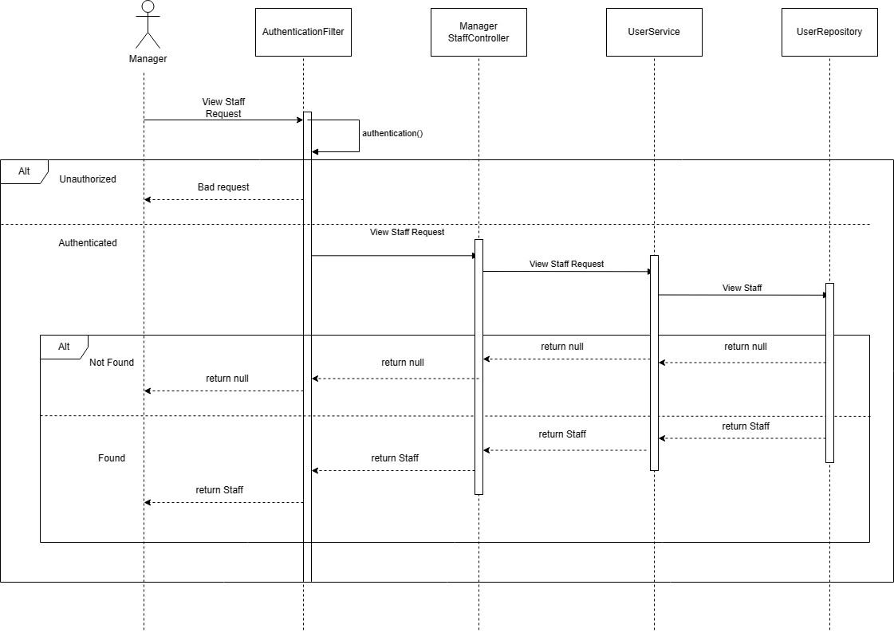

**View Staff List / View Staff**

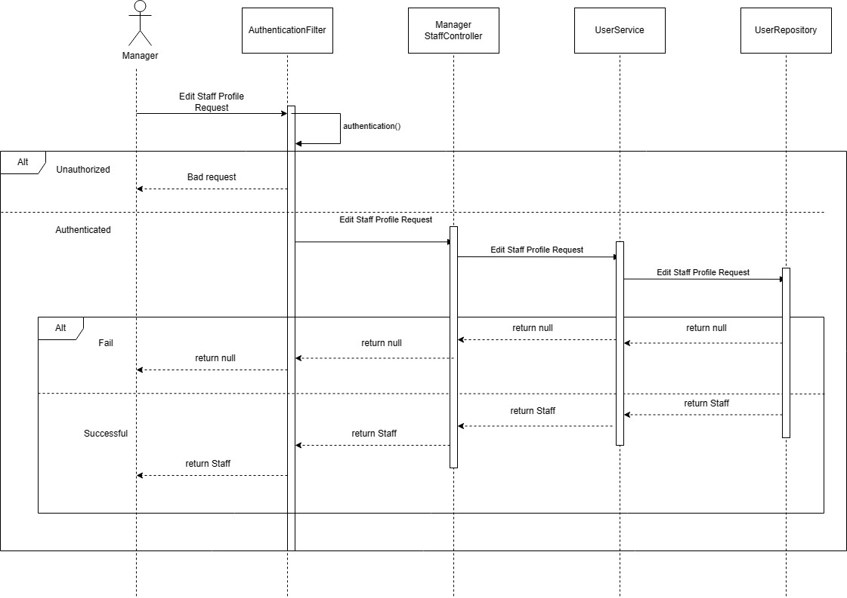

**Edit Staff Profile**

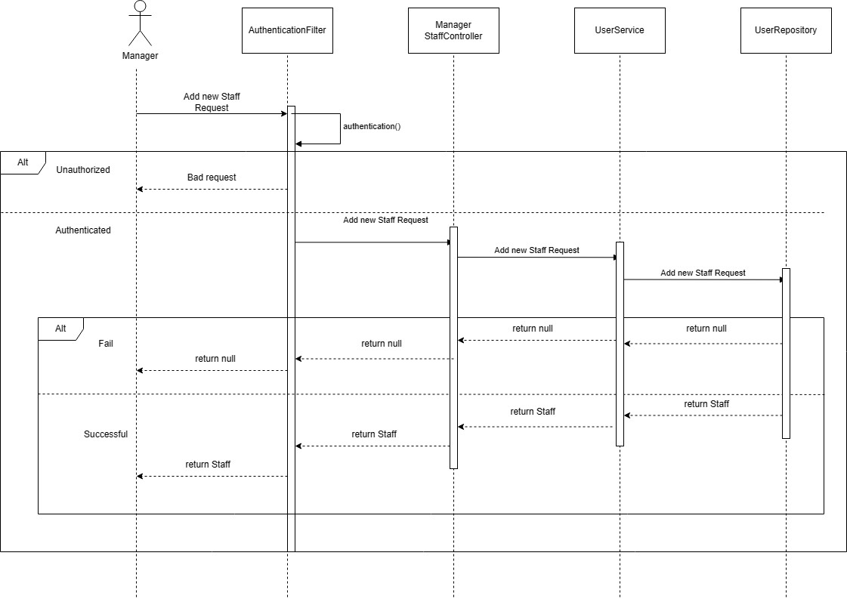

**Add New Staff**

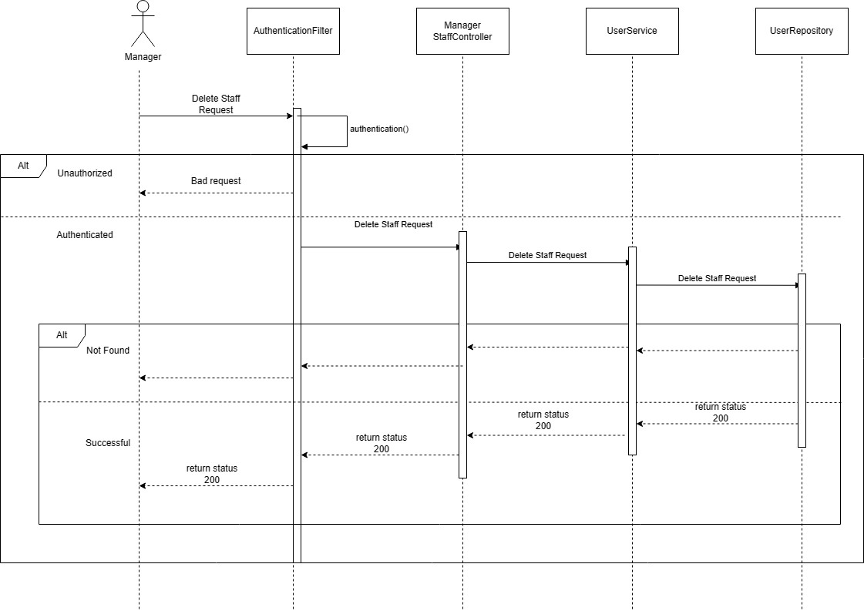

**Delete Staff**

### **d. Database queries**

### **Get user by username**

SELECT u FROM User u WHERE u.username = :username

### **Get user by email**

SELECT u FROM User u WHERE u.email = :email

### **Get user by roleId**

SELECT u FROM User u WHERE u.role.id = :roleId

### **Get user with enabled status by username or email**

SELECT u FROM User u WHERE u.enabled = :enabled and (u.email = :check OR u.username = :check)

### **Get users by role id and enabled**

SELECT u FROM User u WHERE u.role.id = :roleId AND u.enabled = :enabled

### **Update user enabled by username or email**

UPDATE User u SET u.enabled = :enabled WHERE

u.email = :emailOrUsername OR u.username = :emailOrUsername)

### **Filter user by firstname and lastname by role id and enabled**

SELECT u FROM User u

WHERE u.role.id = :roleId

AND u.enabled = :enabled AND (u.username LIKE %:search%

OR u.email LIKE %:search% OR (u.firstName || ' ' || u.lastName LIKE %:search%))".

## 

## **8. <Staff Manage order/View orders/View detail of each order/Refuse/Confirm orders>**

### **a. Class Diagram**

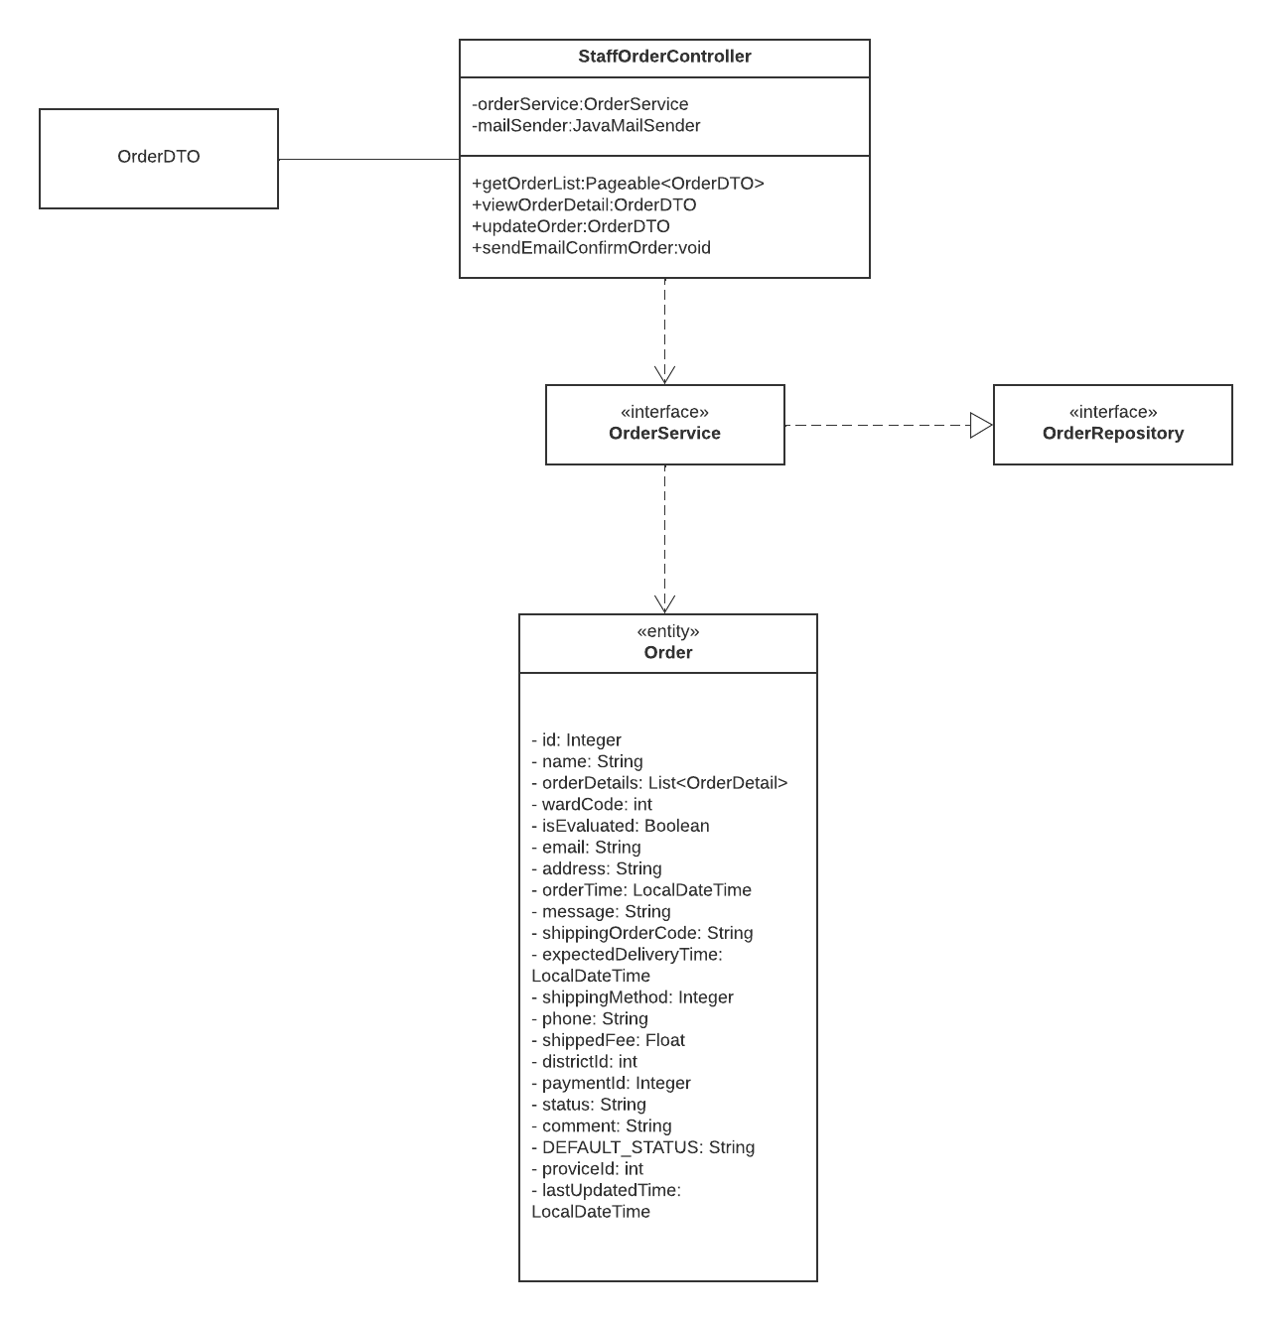

### **b. Class Specifications**

### **c. Sequence Diagram(s)**

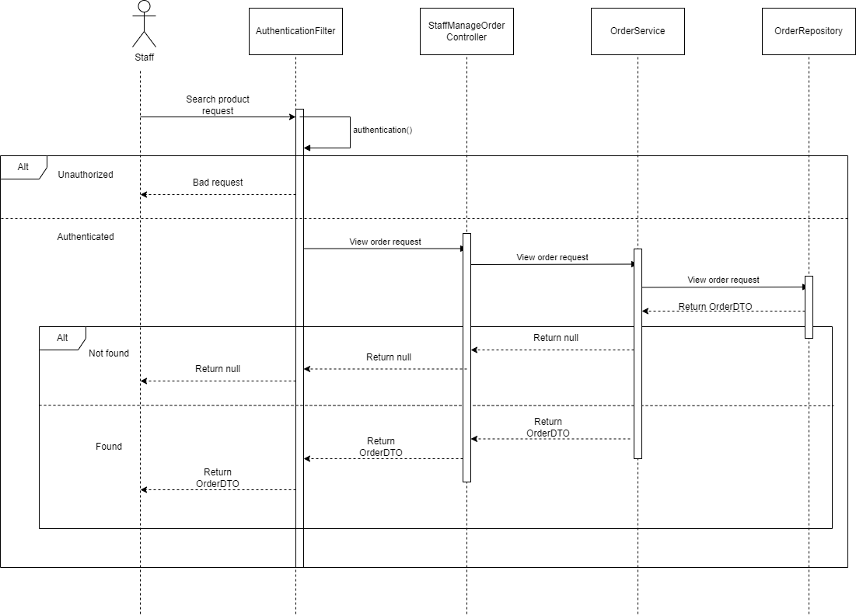

View order diagram

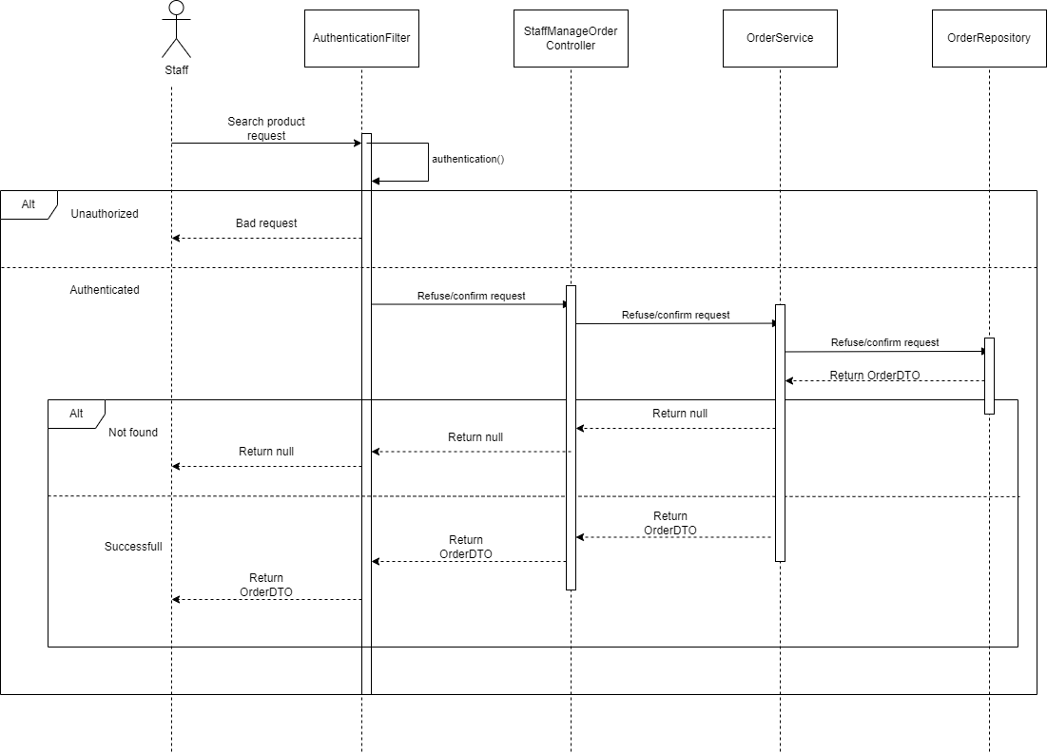

Refuse/Confirm order

### **d. Database queries**

**FindOrderByOrderId**

SELECT o FROM Orders o WHERE o.id = :orderId

**FindOrdersWithoutStatus**

SELECT o FROM Orders o WHERE (o.status NOT IN :status)

**FindOrdersByProductIdWithoutStatus**

SELECT o FROM Orders o WHERE o.status NOT IN :status AND :productId IN (SELECT od.productId FROM o.orderDetails od)

**FindAllByEmail**

SELECT o FROM Orders o WHERE o.email = :email ORDER BY o.orderTime DESC

**FindAllByEmailWithStatus**

SELECT o FROM Orders o WHERE o.email = :email AND o.status in :statuses ORDER BY o.orderTime DESC

**SetStatusOfOrderByOrderId**

UPDATE Orders o SET o.status = :status WHERE o.id = :orderId

**GetOrderedWithStatus**

SELECT p FROM Orders p WHERE p.status like %:status%

**FindSuccessfulOrdersFromTo**

SELECT o FROM Orders o WHERE o.status = 'SUCCESSFUL' AND :startDate <= o.orderTime AND o.orderTime <= :endDate

**FindAllByEmail**

SELECT o FROM Orders o WHERE o.email = :email

**FindOrderByDay**

SELECT o FROM Orders o WHERE :startDate <= o.orderTime AND o.orderTime <= :endDate

## **9. <Statistic>**

### **a. Class Diagram**

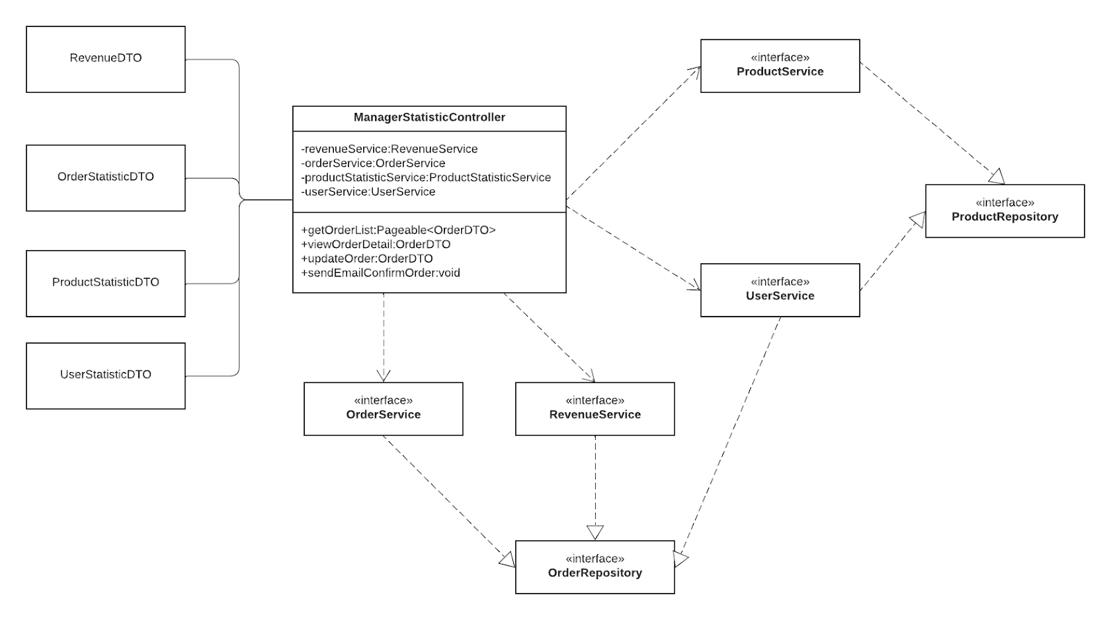

### **b. Class Specifications**

### 

***ManagerStatisticController***

|  |  |  |
| --- | --- | --- |
| **No** | **Method** | **Description** |
| *01* | *getRevenue* | *Parameter:@RequestParam String date. This function will return the RevenueDTO Frontend in date* |
| *02* | *getOrderStatisticsDTO* | *Parameter:@RequestParam String date. This function will return the OrderStatisticDTO Frontend in date* |
| *03* | *getProductStatisticsDTO* | *Parameter:@RequestParam String date. This function will return the ProductStatisticDTO Frontend in date* |
| *04* | *getUserStatisticDTO* | *Parameter:@RequestParam String date. This function will return the UserStatisticDTO Frontend in date* |

***OrderService***

|  |  |  |
| --- | --- | --- |
| **No** | **Method** | **Description** |
| *01* | *getOrderStatistic* | *Parameter:String date. This function will return a OrderStatisticDTO is that OrderStatistic of this date* |

***RevengeService***

|  |  |  |
| --- | --- | --- |
| **No** | **Method** | **Description** |
| *01* | *getRevenue* | *Parameter:String date. This function will return a RevenueDTO of that statistic in date* |

***UserService***

|  |  |  |
| --- | --- | --- |
| **No** | **Method** | **Description** |
| *01* | *getUserStatistic* | *Parameter:String date. This function will return a UserStatistic of that statistic in date* |

***ProductStatisticService***

|  |  |  |
| --- | --- | --- |
| **No** | **Method** | **Description** |
| *01* | *getProductStatistic* | *Parameter:String date. This function will return a ProductStatisticDTO of that statistic in date* |

### **c. Sequence Diagram(s)**

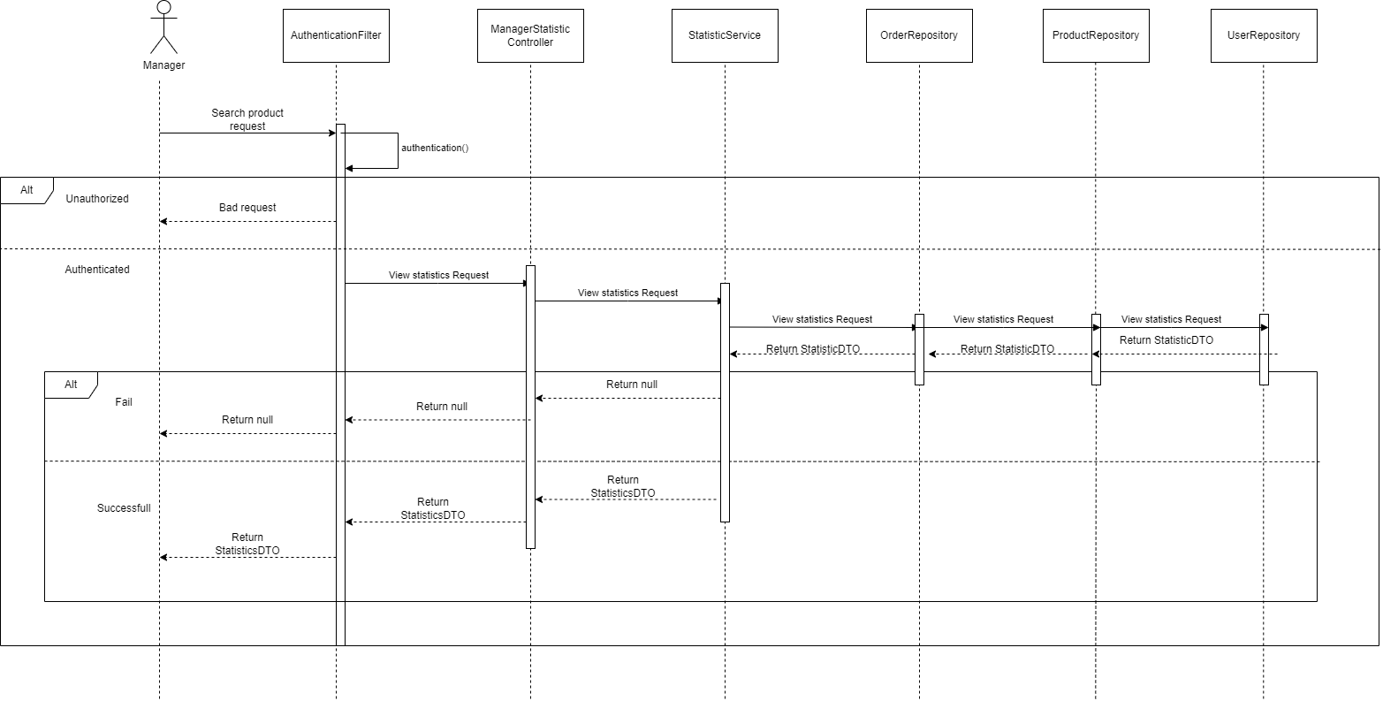

### **d. Database queries**

**getRevenueFromTo**

SELECT SUM(od.price * od.quantity) FROM Orders o JOIN o.orderDetails od

WHERE o.status = 'SUCCESSFUL'

AND :startDate <= o.orderTime

AND o.orderTime <= :endDate

**findTopSoldProductFromTo**

SELECT od.productId FROM Orders to JOIN

o.orderDetails od WHERE

o.status = 'SUCCESSFUL'

AND :startDate <= o.orderTime

AND o.orderTime <= :endDate

GROUP BY od.productId

ORDER BY SUM(od.quantity) DESC

**findTopRatingProductFromTo**

SELECT od.productId FROM Orders o JOIN

o.orderDetails od WHERE

o.status = 'SUCCESSFUL'

AND :startDate <= o.orderTime

AND o.orderTime <= :endDate

GROUP BY od.productId

ORDER BY AVG(od.rating) DESC

**findAllByOrderCountDesc**

SELECT u.* FROM user u

LEFT JOIN (SELECT o.email, COUNT(*) AS order_count FROM orders o GROUP BY o.email) o

ON u.email = o.email

WHERE o.order_count > 0

ORDER BY o.order_count DESC

**findAllByProductCountDesc**

SELECT u.* FROM user u

LEFT JOIN ( SELECT o.email, COUNT(od.id) AS total_products FROM orders o

LEFT JOIN order_detail od ON o.id = od.order_id where o.status='SUCCESSFUL' GROUP BY o.email) t

ON u.email = t.email

WHERE total_products > 0

ORDER BY t.total_products DESC

**findAllOrderByTotalSpentDesc**

SELECT u.* "

FROM user u

JOIN orders o ON u.email = o.email

JOIN order_detail od ON o.id = od.order_id

WHERE o.status = 'SUCCESSFUL'

GROUP BY u.email, u.username, u.address

ORDER BY SUM(od.price * od.quantity) DESC

# **III. Database Tables**

## **1. <Order>**

*Order tables are commonly used in retail or e-commerce systems to store information about customer orders. The table will contain fields like the id , email of the customer and info date and order address of the order ()*

|  |  |  |  |  |  |  |  |
| --- | --- | --- | --- | --- | --- | --- | --- |
| **#** | **Field name** | **Type** | **Size** | **Unique** | **Not Null** | **PK/FK** | **Notes** |
| 1 | id | INT | 4 |  | X | PK | Unique identifier for each order |
| 2 | email | VARCHAR | 255 |  | X | FK | Reference user(email)  Email address of the customer who placed the order. |
| 3 | payment_id | INT | 4 |  |  | FK | Unique identifier for the payment  Reference user(payment_method) |
| 4 | shipping_order_code | VARCHAR | 45 |  |  |  | This column stores a unique identifier for each shipping order. |
| 5 | shipping_method | INT | 4 |  |  |  | This column stores the method used to ship the order, such as air mail, ground shipping or express delivery. |
| 6 | shipping_fee | FLOAT | 4 |  |  |  | This column stores the amount charged for shipping the order. |
| 7 | expected_delivery_time | DATETIME | 8 |  |  |  | This column stores the estimated date and time when the order will be delivered. |
| 8 | shipped_date | DATETIME | 8 |  |  |  | This column stores the actual date and time when the order was shipped. |
| 9 | name | VARCHAR | 64 |  |  |  | This column stores the name of the recipient who placed the order |
| 10 | phone | VARCHAR | 20 |  |  |  | This column stores the phone number of the recipient |
| 11 | address | VARCHAR | 400 |  |  |  | This column stores the street address where the order should be delivered. |
| 12 | ward_code | INT | 4 |  |  |  | This column stores a code that identifies the ward or sub-district of the delivery address. |
| 13 | district_id | INT | 4 |  |  |  | This column stores an identifier for the district or city of the delivery address. |
| 14 | province_id | INT | 4 |  |  |  | This column stores an identifier for the province or state of the delivery address. |
| 15 | status | INT | 4 |  |  |  | This column stores the current status of the order. |
| 16 | status_comment | VARCHAR | 100 |  |  |  | This column stores any comments or notes related to the status of the order. |
| 17 | last_updated_time | DATETIME | 8 |  |  |  | This column stores the date and time when the status of the order was last updated. |
| 18 | is_evaluated | TINYINT | 1 |  |  |  | This column stores a flag indicating whether the customer has provided feedback or evaluation of the order. |

## **2. <Order Detail>**

The "Order Detail" table is a relational database table that stores information about each product ordered in an order. This table usually has a foreign key constraint that links it to the "Order" table and the "Product" table.

|  |  |  |  |  |  |  |  |
| --- | --- | --- | --- | --- | --- | --- | --- |
| **#** | **Field name** | **Type** | **Size** | **Unique** | **Not Null** | **PK/FK** | **Notes** |
| 1 | id | INT | 4 |  | X | PK | The unique identifier for each item in the OrderDetail |
| 2 | order_id | INT | 4 |  | X | FK | Reference Order(id)  The unique identifier for the order |
| 3 | product_id | INT | 4 |  | X | FK | Reference product(id)  The unique identifier for the product |
| 4 | price | FLOAT | 4 |  |  |  | The price of the item |
| 5 | quantity | INT | 4 |  |  |  | The number of units of the product |
| 6 | feedback | VARCHAER | 400 |  |  |  | Teedback provided by customers or users. |
| 7 | rating | FLOAT | 4 |  |  |  | The rating given by customers or users |
| 8 | feedback_time | DATETIME | 8 |  |  |  | This column stores the date and time when the feedback was provided. |

## **3. <payment_method>**

The payment_method table is a database table that stores information about different payment methods that can be used to make payments in a system

|  |  |  |  |  |  |  |  |
| --- | --- | --- | --- | --- | --- | --- | --- |
| **#** | **Field name** | **Type** | **Size** | **Unique** | **Not Null** | **PK/FK** | **Notes** |
| 1 | id | INT | 4 |  | X | PK | Unique identifier for each payment method |
| 2 | name | INT | 120 |  |  |  | The name of the payment method |

## 

## **4. <cart>**

The "cart" table is a crucial component of a database designed to handle the shopping cart functionality in an e-commerce or web-based application. It is responsible for storing information about the items selected by users for purchase before they proceed to checkout.

|  |  |  |  |  |  |  |  |
| --- | --- | --- | --- | --- | --- | --- | --- |
| **#** | **Field name** | **Type** | **Size** | **Unique** | **Not Null** | **PK/FK** | **Notes** |
| 1 | id | INT | 4 |  | X | PK | identity column |
| 2 | email | VARCHAR | 255 |  | X | PK | reference user(email)  Cart of each user. |
| 3 | product_id | INT | 4 |  | X | FK | reference product(id)  Product of each cart. |
| 4 | quantity | INT | 4 |  | X |  | Quantity of each product in cart. |
| 5 | last_time_update | DATETIME | 8 |  |  |  | Last time update by user. |

## **5. <category>**

The “category” table serves as a foundational structure for organizing and categorizing products, facilitating efficient search, navigation, and management of product data.

|  |  |  |  |  |  |  |  |
| --- | --- | --- | --- | --- | --- | --- | --- |
| **#** | **Field name** | **Type** | **Size** | **Unique** | **Not Null** | **PK/FK** | **Notes** |
| 1 | id | INT | 4 |  | X | PK | -reference product(category_id)  identity column  Product category for filter,... |
| 2 | name | VARCHAR | 45 | X | X |  | Name of each category. |
| 3 | status | TINYINT | 1 |  | X |  |  |

## 

## 

## **6. <user>**

The “user” table stores information about the users of the system, allowing for authentication, authorization, and personalized functionality

|  |  |  |  |  |  |  |  |
| --- | --- | --- | --- | --- | --- | --- | --- |
| **#** | **Field name** | **Type** | **Size** | **Unique** | **Not Null** | **PK/FK** | **Notes** |
| 1 | email | VARCHAR | 255 |  | X | PK | identity column  -reference cart(email)  Each cart of user  -reference order(email)  Order of user  -reference review(email)  All review of user |
| 2 | role_id | INT | 4 |  |  | FK | reference role(id)  identity each role of user |
| 3 | username | VARCHAR | 45 | X | X |  | The username chosen by the user |
| 4 | password | VARCHAR | 80 |  | X |  | The encrypted password for user authentication |
| 5 | first_name | VARCHAR | 50 |  | X |  | The first name of the user. |
| 6 | last_name | VARCHAR | 50 |  |  |  | The last name of the user. |
| 7 | phone | VARCHAR | 20 |  |  |  | Phone number of user. |
| 8 | yob | INT | 4 |  |  |  | Year of birth of user. |
| 9 | avatar | VARCHAR | 1000 |  |  |  | The avatar was chosen by the user. |
| 10 | address | VARCHAR | 400 |  |  |  | Address of user. |
| 11 | ward_id | INT | 4 |  |  |  | Ward of the user. |
| 12 | enabled | TINYINT | 1 |  |  |  | Status of user in website(ban/unbanned) |
| 13 | reset_password_token | VARCHAR | 45 |  |  |  | Token that is generated when a user requests a password reset |
| 14 | expired_vertification_code | DATETIME | 8 |  |  |  | An expiration timestamp for a verification code that was sent to a user for some purpose |
| 15 | gender | BIGINT | 8 |  |  |  | Used to store information about an individual's gender identity |

## **7. <role>**

The "role" table is a common component of a database designed to manage user roles and permissions in a web application. It allows for the definition and assignment of different roles to users, controlling their access to certain features and resources.

|  |  |  |  |  |  |  |  |
| --- | --- | --- | --- | --- | --- | --- | --- |
| **#** | **Field name** | **Type** | **Size** | **Unique** | **Not Null** | **PK/FK** | **Notes** |
| 1 | id | INT | 4 |  | X | PK | reference user(email)  identity role of each user |
| 2 | name | VARCHAR | 45 | X | X |  | The name or title of the role |

## **8. <product>**

The table 'product' is a database table that typically stores information related to various products within a system or organization. The 'product' table typically contains several columns to store specific details about each product. The 'product' table typically contains several columns to store specific details about each product.

|  |  |  |  |  |  |  |  |
| --- | --- | --- | --- | --- | --- | --- | --- |
| **#** | **Field name** | **Type** | **Size** | **Unique** | **Not Null** | **PK/FK** | **Notes** |
| 1 | id | INT | 4 |  | X | PK | What identify of each product |
| 2 | name | VARCHAR | 200 |  | X |  | The name of the product |
| 3 | description | VARCHAR | 1000 |  |  |  | The description of the product |
| 4 | quantity | INT | 4 |  | X |  | The quantity of the product |
| 5 | price | FLOAT | 4 |  | X |  | The price of the product |
| 6 | category_id | INT | 4 |  |  | FK | Reference category(id) |
| 7 | last_updated_time | DATETIME | 8 |  |  |  | The last time that the product was edited |
| 8 | last_updated_by | VARCHAR | 255 |  |  | FK | The last user that edited the product |
| 8 | status | TINYINT | 1 |  | X |  | The status of the product |
| 9 | avatar | VARCHAR | 1000 |  |  |  | The image of the product |

## **9. <product_image>**

The table "product_image" typically stores information related to images associated with products.

|  |  |  |  |  |  |  |  |
| --- | --- | --- | --- | --- | --- | --- | --- |
| **#** | **Field name** | **Type** | **Size** | **Unique** | **Not Null** | **PK/FK** | **Notes** |
| 1 | id | INT | 4 |  | X | PK | What identify of each product image |
| 2 | url | VARCHAR | 1000 |  | X |  | URL of image of product |
| 3 | product_id | INT | 4 |  |  | FK | Reference product(id) |
| 4 | is_main | TINYINT | 1 |  |  |  | This image is avatar or not |